UNITED STATES TRANSPORTATION COMMAND (USTRANSCOM)

Program Executive Office -TRANSCOM (PEO-T)

Defense Personal Property System (DPS)

Rate Filing User Guide
Transportation Service Provider (TSP) Edition
Version 07
February 10, 2015
Project Manager: Mitchell M. Miller

Prepared for:
USTRANSCOM ACQUISITION/TCAQ
Attention: Robert L. Massie
508 Scott Drive
Scott AFB, IL 62225-5357

Prepared by:
CACI, INC. – FEDERAL

Contract Number: HC1028-08-D-2016-6S01
Task 1, Paragraph 1.4.4; CDRL Data Item A010
Document Control Number (DCN): 07974-0023-02-04-rev2-318

Document Change History
The following is a history of changes to versions of this user guide for the Defense Personal Property System (DPS).
Date | Version | Change Description
3/1/11 | 01 | Initial Draft (Delivered by SRA under Contract Number HC1028-08-D-2026-6S01)
3/29/11 | 01 | Document accepted by Government 3/24/11 (Delivered by SRA under Contract Number HC1028-08-D-2026-6S01)
7/8/13 | 02 | Revised for DPS Release 1.6.0, DCN: 013808-04-134-D1-258 (Delivered by SRA under Contract Number HC1028-08-D-2026-6S01)
7/23/13 | 03 | Updated to incorporate Government comments. DCN: 013808-04-134-258 (Delivered by SRA under Contract Number HC1028-08-D-2026-6S01)
10/22/14 | 04 | Initial Draft for DPS Version 2.0.0, DCN: 07974-0023-02-04-D1-318
10/22/14 | 05 | Initial Draft for DPS Version 2.0.0, DCN: 07974-0023-02-04-318
2/9/15 | 06 | Updated to address Government comments. DCN: 07974-0023-02-04-rev1-318
2/10/15 | 07 | Updated by SDDC. DCN: 07974-0023-02-04-rev2-318

Table of Contents
1 Rate Filing at a Glance 1
2 Introduction 7
2.1 Objectives 7
2.2 DPS Program Requirements for Rate Filing 8
2.3 Types of Annual Rates and Daily RFQ Bids 8
2.3.1 Annual/Standard Rates 8
2.3.2 Bidding Rounds 9
2.3.3 The Annual Rate Cycle 9
2.3.4 Daily Solicitations 9
2.3.5 Rate Filing Process 10
2.4 Rate Filing Methods 10
3 File Annual rates with Workbench 11
3.1 Access the Workbench 11
3.2 Filter Rate Filing Channels 13
3.3 Rate Entry and Submission 15
3.3.1 Round 2 17
3.4 Undo Options 18
3.5 Special Solicitation Shipments 19
4 Bulk Rate Filing 20
4.1 Prepare a Bulk Rate File 20
4.1.1 Standard Annual Rates 20
4.1.2 Special Solicitation Annual Rates 21
4.1.3 Data Element Information 22
4.2 How to Upload Bulk Rates 25
4.3 Bulk Rate Validation 28
4.3.1 Immediate Onscreen Validation 28
4.3.2 Overnight Validation 28
4.3.3 Validation at End of Round 32
5 One-Time-Only Shipments 34
5.1 Types of One-Time-Only Shipments 34
5.1.1 Boat Dimension Limits 34
5.2 Requirements 34
5.3 OTO Shipment Process – A high level overview 35
5.4 The One Time Only Queue 36
5.5 How to Bid on a One-Time-Only Shipment 37
5.5.1 Bid on an OTO Solicitation 37
5.5.2 Edit an OTO Bid 40
5.6 How to Review Current OTO Awards 41
5.7 How to Enter a Remark on an OTO Solicitation 42
5.8 Search For An OTO Shipment 46
5.9 Viewing the OTO Awards History page 46
6 Volume Move 47
6.1 Volume Move Requirements 47
6.1.1 Eligibility 47
6.1.2 Bid Solicitation Period 47
6.1.3 Bid Format 47
6.1.4 Bid Acceptance 47
6.1.5 Email Notification 47
6.1.6 Volume Move Page Tabbed Interface 48
6.1.7 Volume Move Details Page Tabbed Interface 48
6.2 How to Bid on a Volume Move 48
6.3 How to Edit a Bid on a Volume Move 51
6.4 How to Cancel a Bid on a Volume Move 54
Appendix A: Acronyms and Abbreviations 57
Appendix B: TSP Email Notifications (Rates Module) 58

List of Figures
Figure 2-1. DPS Rate Filing Process Flow 10
Figure 3-1: Rates Welcome Page 11
Figure 3-2. Rates Welcome Page 11
Figure 3-3. Rate Filing Workbench Page 12
Figure 3-4. Rate Filing Workbench Page – Channel View 12
Figure 3-5. Rate Filing Workbench Page – Filter Options 13
Figure 3-6. Rate Filing Workbench Page – Filter Results 14
Figure 3-7. Rate Filing Workbench Page – Error Message 15
Figure 3-8. Rate Filing Workbench Page – Submit Rates 16
Figure 3-9. Rate Filing Workbench Page – Submission Confirmed 16
Figure 3-10. Rate Filing Workbench Page – Accepted Rates 17
Figure 3-11. Rate Filing Workbench Page – Undo Selected 18
Figure 3-12. Rate Filing Workbench Page – Special Solicitation 19
Figure 4-1. Bulk Rate File Example for Domestic Standard Solicitations 20
Figure 4-2. Bulk Rate File Example for International Standard Solicitations 21
Figure 4-3. Bulk Rate File Example for Special Solicitations 21
Figure 4-4. Rates Welcome Page 25
Figure 4-5. Upload Bulk Rates Page – Select Rate Type 25
Figure 4-6. Upload Bulk Rates Page – Browse 26
Figure 4-7. Windows Choose File Dialog Box 26
Figure 4-8. Upload Bulk Rates Page – Submit 27
Figure 4-9. Upload Bulk Rates Page – Confirmation 27
Figure 4-10. Bulk Rates Overnight Exception Email 31
Figure 4-11. Bulk Rates Round Exception Email 33
Figure 5-1. The One Time Only Queue 36
Figure 5-2. One Time Only Queue – Filtered for an iOTO 37
Figure 5-3. Shipment Details Page – iOTO Shipment Tab 38
Figure 5-4. Shipment Details Page – Bid Info Tab 38
Figure 5-5. Shipment Details Page – Bid Info Tab – Enter an iOTO Bid 38
Figure 5-6. Shipment Details Page – Bid Info Tab – Enter a BOTO Bid 39
Figure 5-7. Shipment Details Page – Bid Info Tab – Enter a MOTO Bid 39
Figure 5-8. Shipment Details Page – Bid Info Tab – Bid Saved 40
Figure 5-9. Shipment Details Page – Bid Info Tab – Edit an iOTO Bid 40
Figure 5-10. Access the Current Awards Tab 41
Figure 5-11. Current Awards Tab 41
Figure 5-12. One Time Only Queue 42
Figure 5-13. Shipment Details Page – Shipment Tab 42
Figure 5-14. Shipment Details Page – Bid Info Tab 43
Figure 5-15. TSP Remarks Dialog Box, Not in Edit Mode, with No Previous Remarks 43
Figure 5-16. TSP Remarks Dialog Box, Not in Edit Mode, with Remarks 43
Figure 5-17. Shipment Details Page – Bid Info Tab – Edit Mode 44
Figure 5-18. TSP Remarks Dialog Box, in Edit Mode, with No Previous Remarks 44
Figure 5-19. TSP Remarks Dialog Box, in Edit Mode, with Remarks 44
Figure 5-20. Enter a TSP Remark 44
Figure 5-21. Add Another Remark or Close 45
Figure 5-22. TSP Remarks Dialog Box Ready to Enter a Second Remark 45
Figure 5-23. Shipment Details Page – Save or Cancel Remark 45
Figure 5-24. OTO Search Page 46
Figure 5-25. OTO Awards History Page 46
Figure 6-1. Rates Welcome Page 48
Figure 6-2. Volume Move – Select a SCAC 49
Figure 6-3. Volume Move – Select a Volume Move Number 49
Figure 6-4. Volume Move Details Page 50
Figure 6-5. Volume Move Details Page – Place a Bid 50
Figure 6-6. Rates Welcome Page 51
Figure 6-7. Volume Move – Select a SCAC 51
Figure 6-8. Volume Move – Select a Volume Move Number 52
Figure 6-9. Volume Move Details Page 52
Figure 6-10. Volume Move Details Page – Bid Details Tab 53
Figure 6-11. Volume Move – Edit Bid Page 53
Figure 6-12. Rates Welcome Page 54
Figure 6-13. Volume Move – Select a SCAC 54
Figure 6-14. Volume Move – Select a Number 54
Figure 6-15. Volume Move Details Page 55
Figure 6-16. Volume Move – Cancel Bid 55
Figure 6-17. Volume Move Bid Cancellation Confirmation 56

List of Tables
Table 2-1. User Role Access 7
Table 2-2. Rate Filing Methods 7
Table 2-3. Solicitations and Rate Filing Details 9
Table 4-1. Domestic File Format 22
Table 4-2. International File Format 23
Table 4-3. Special Solicitation File Format 24
Table 4-4. Bulk Rate Validation – Overnight Exceptions 29
Table 4-5. Annual Rate Rejection – at End of Round 32
Table 5-1. One-Time-Only Shipment Types 34
Table 5-2. Example OTO Number Filters 36

Rate Filing at a Glance
This section offers a guide to the most common tasks in the Rates Module for a Transportation Service Provider (TSP). Each title bar for a task described below includes a reference to the section of this guide that provides additional details about the task. All rates, BVS, and SCACs used in this guide are fictitious and do not represent valid carrier information.

File Annual Rates with Workbench See Section 3

To file a standard annual rate, first select the Rates tab to access the Rates module. Then:
- Select the Workbench option in the left navigation bar. Rate Filing Representatives must select a SCAC to continue.
- Select a Market (dHHG, iHHG, iUB, SS iHHG, or SS iUB). By default, DPS presents all channel and Code of Service (COS) combinations a TSP is qualified to bid on.
- To filter the listed channels, or to access a specific channel or COS, select one or more criteria or checkboxes and select the Apply Filter option.
- Enter Line Haul and SIT discount or Single Factor Rates for one or more of the listed channels. Rate options vary according to Market Type.
- Select the Submit option to update the values stored in the system.

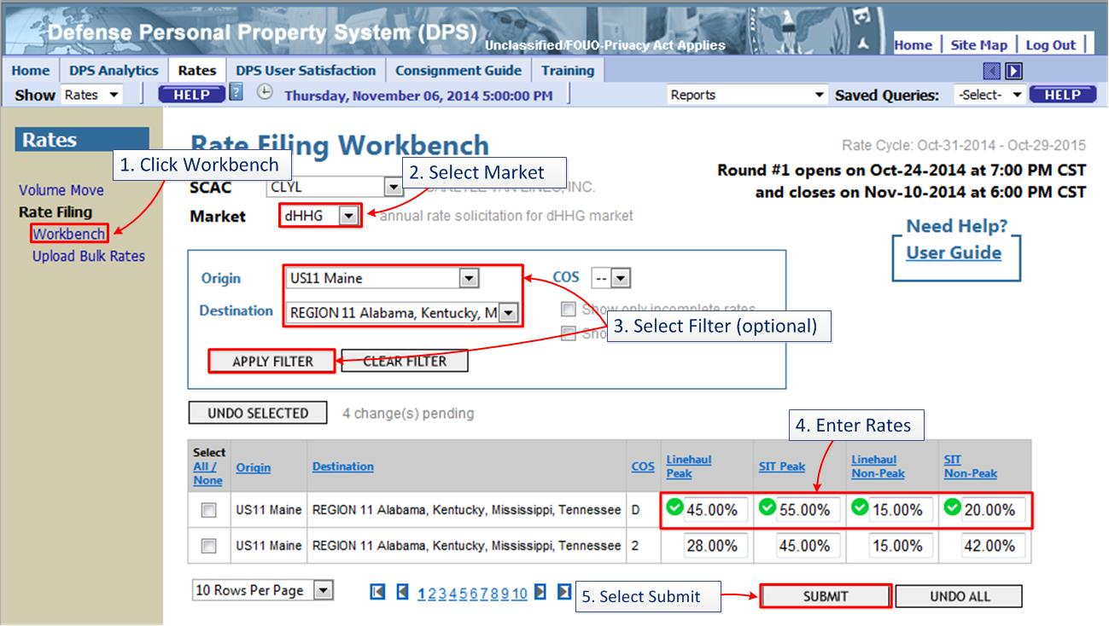
Use the Select checkbox, or the Select All function, and then use the Undo Selected or Undo All option to restore values for rates entered in the previous submission.
File Annual Rates with Upload Bulk Rate See Section 0

To file annual rates housed in a .csv bulk file, select the Rates tab to access the Rates module. Rate Filing Representatives must select a SCAC to continue. To complete the process:
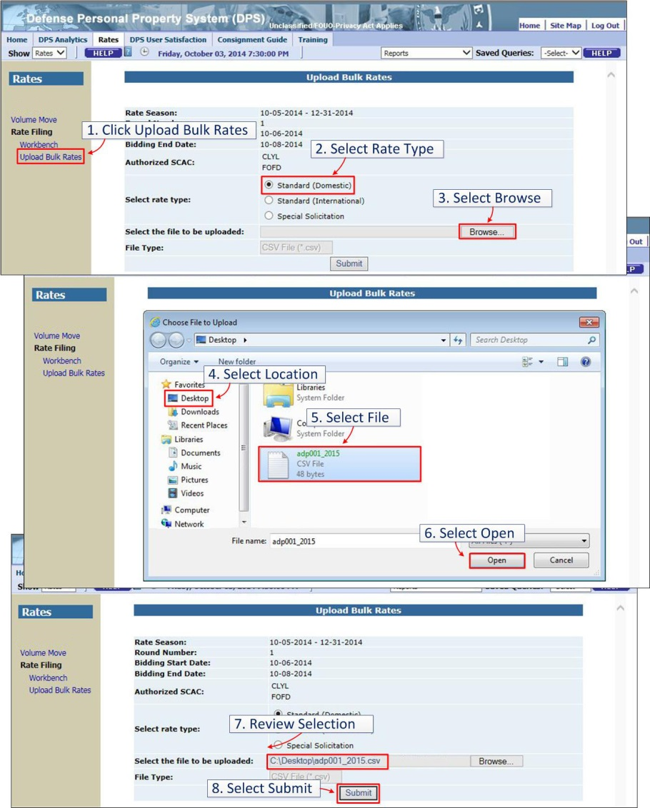
- Select the Upload Bulk Rates option in the left navigation bar.
- Select a Rate Type (Standard Domestic, International or Special Solicitation).
- Select the Browse option. DPS will present a pop-up window used to select a file.
- In the Choose File to Upload pop-up window, select a Location and navigate to the folder where the .csv bulk rate file is located.
- Select the bulk rate file. DPS will populate the name of the file in the File Name field.
- Select the Open option. DPS will close the pop-up window and present the path and file name.
- Review to validate the correct file is selected.
- Select the Submit option to upload the file.
- DPS presents a confirmation message following submission of the bulk rate file. The message indicates the name assigned to the file by the system.
- Bulk Rate Files are transferred into Workbench based on Date & Time of the Bulk Rate File submitted and successfully uploaded.

Bid on a One-Time-Only (OTO) Shipment See Section 5.5
To bid on an OTO shipment:
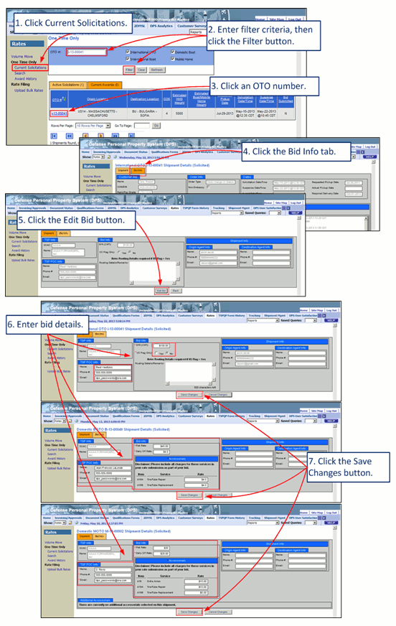
- Select Current Solicitations under One Time Only on the Rates menu.
- Enter filter criteria, and then select the Filter option.
- Select the OTO number of the solicitation for which you want to enter a bid.
- Select the Bid Info tab.
- Select the Edit Bid option.
- Enter your bid details, including TSP POC Info and all applicable rate information. Note: Selecting “Yes” for the iOTO question “US Flag Only,” will require entry of data in the Routing Details/Remarks field.
- Select the Save Changes option.

Enter a One-Time-Only (OTO) Remark See Section 0
To enter a remark on an OTO shipment:
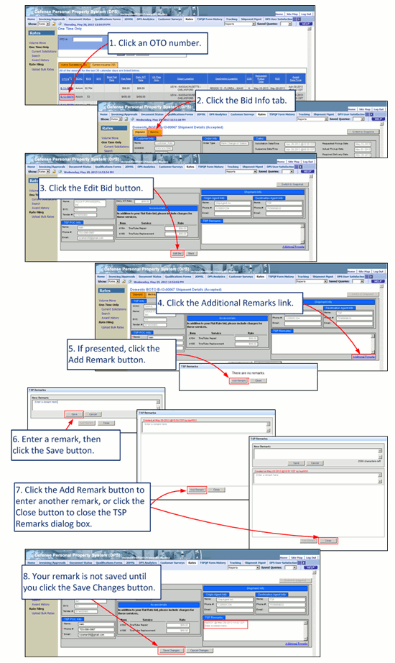
- Select the OTO number of a solicitation.
- Select the Bid Info tab.
- Select the Edit Bid option.
- Select the Additional Remarks link.
- Select the Add Remark option.
- Enter a remark, and then select the Save option.
- Select the Add Remark option to enter another remark, or select the Close option to close the dialog box and return to the Shipment Details page.
- Select the Save Changes option.

NOTE: Remarks are not saved until the Save Changes option is used.

Bid on a Volume Move (VM) See Section 6.2
To bid on a Volume Move:
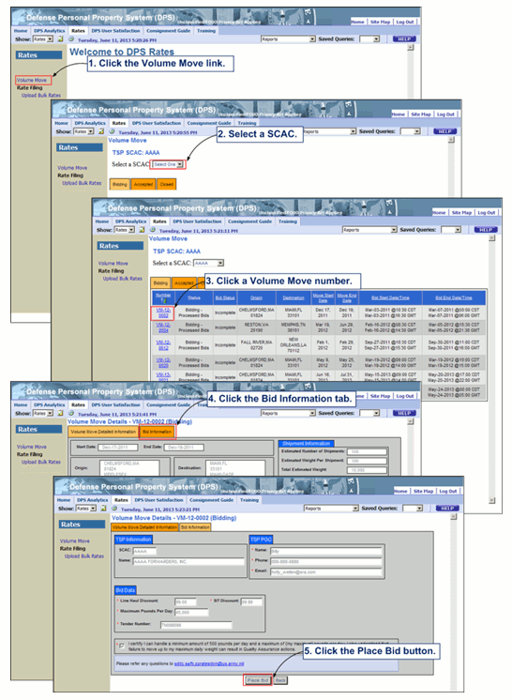
- On the Rates tab, select the Volume Move link on the Rates menu.
- Rate Filing Representatives must select a Standard Carrier Alpha Code (SCAC) from the Select a SCAC list.
- Select an actively bidding Volume Move Number to open that Volume Move.
- Review all data on the Volume Move Detailed Information tab, and then select the Bid Information tab.
- Complete all required fields, and then select the Place Bid option.

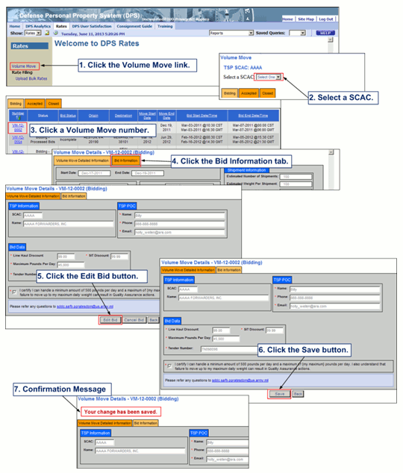
Edit a Volume Move Bid See Section 0
To edit a Volume Move bid:
- On the Rates tab, select the Volume Move link on the Rates menu.
- Rate Filing Representatives must Select a SCAC.
- Select an actively bidding Volume Move Number.
- Select the Bid Information tab.
- Select the Edit Bid option.
- Edit the fields and then select the Save option.
- DPS presents a confirmation message: “Your change has been saved.”

Delete a Volume Move Bid See Section 6.4
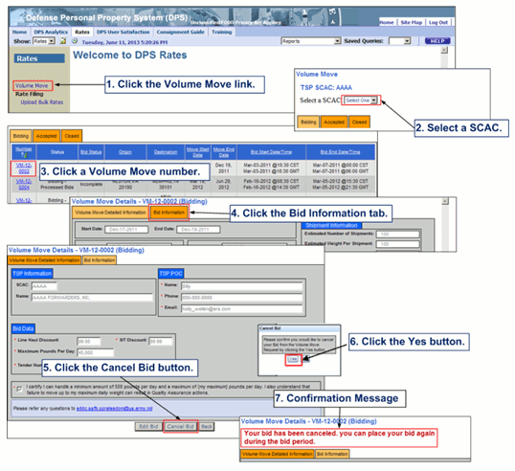
To delete a Volume Move bid:
- On the Rates tab, select the Volume Move link on the Rates menu.
- Rate Filing Representatives must select a SCAC from the Select a SCAC list.
- Select an actively bidding Volume Move Number.
- Select the Bid Information tab.
- Select the Cancel Bid option.
- In the Cancel Bid dialog box, select the Yes option.
- DPS presents a confirmation message: “Your bid has been canceled. You can place your bid again during the bid period.”

Introduction

Objectives
This guide explains how Transportation Service Providers (TSPs) may respond to Defense Personal Property Program (DP3) solicitations using the rate filing functions within DPS. This guide offers instructions for the submission of annual rates, and functions used to submit bids in response to daily One-Time-Only and Volume Move solicitations. See Table 2-1, below for user role access limitations.
Table 2-1. User Role Access
User Role | Ability to File a Rate or Bid | Read-Only Access
TSP Master | X
TSP Rate Filing Representative | X
TSP Administrator |  | X
TSP Quality Assurance (QA) |  | X
TSP Operation Manager | Volume Move or One-Time-Only

See Table 2-2, below for available rate filing methods.
Table 2-2. Rate Filing Methods
 | Workbench | Bulk Rate | Volume Move | One-Time-Only
Annual Rates (Low Volume) | X
Annual Rates (High Volume) |  | X
Multiple TSP Support |  | X
Respond to Multiple Solicitations |  | X
Daily Bids |  |  | X | X
Interface | Web-Based | Text File | Web-Based | Web-Based

Tasks covered in this guide include:
  - Filing annual rates using the Workbench and Bulk Rate Filing
  - Accessing annual and daily solicitations
  - Bidding on daily solicitations, including Volume Move and One-Time-Only (OTO)
  - Viewing the status of all rates and daily solicitations

DPS Program Requirements for Rate Filing
To file annual rates in DPS, a TSP must meet the following program requirements:
  - Certificate of Independent Pricing (CIP)/Certificate of Responsibility (COR) submitted during the annual Qualification Open Season.
  - Registration on the SDDC ETA single-sign on portal for access to DPS
  - SDDC approval for one or more DPS markets:
  - Domestic Household Goods (dHHG)
  - International Household Goods (iHHG)
  - International Unaccompanied Baggage (iUB)
For more details on these markets, see Table2-3, below.
NOTE: If a TSP does not file rates for two (2) consecutive rate cycles, approval is revoked and the TSP may not participate in the program. To regain approval, reapply during a Qualification Open Season.

Types of Annual Rates and Daily RFQ Bids
DPS Rates allows TSP Master and Rate Filing Representatives to submit annual rates for standard shipments awarded during an upcoming rate cycle and to submit bids online for daily solicitations.

Annual/Standard Rates
TSP Master and Rate Filing Representatives can submit rates for the solicitations listed in Table 2-3.
During each Round, all rates must be submitted in complete sets (as defined below) in order for the rate to be considered for acceptance for that Rate Cycle.
Channel Sets include:
- dHHG: LH & SIT Peak and LH & SIT Non-Peak Discount (%)
- iHHG: Peak & Non-Peak SFR ($)
- iUB: Peak & Non-Peak SFR ($)
- SS iHHG: Peak & Non-Peak SFR ($)
- SS iUB: Peak & Non-Peak SFR ($)

TSPs who do not submit complete sets will not have their rates accepted.
NOTE: Bid sets will be identified as incomplete and processed in accordance with section 4.3.3.

Table 2-3. Solicitations and Rate Filing Details
Domestic Solicitations
dHHG (Domestic Household Goods) | Rates are filed annually against the 400NG Tariff with discounts for Line Haul (LH), Storage In Transit (SIT), and related charges. File Peak and Non-Peak bids for each channel/COS of interest.
International Solicitations
iUB (International Unaccompanied Baggage)  iHHG (International Household Goods)  Special Solicitation (SS) iHHG  Special Solicitation (SS) iUB | Rates are filed annually against the International Tender for each channel (standard or special). File two Single Factor Rates (SFR) – one for Peak and one for Non-Peak.

Bidding Rounds
Rates are filed in two rounds of bidding. TSPs are notified of errors when submitting rates, as they are immediately identified onscreen. Rate rejections are identified in an email notification delivered to the TSP at the end of each round of bidding.
Rates filed using the Bulk Rate filing method undergo additional validation within twenty-four hours of submission. If errors are found in this validation, a TSP will receive an email describing the error.
Please note the following bidding rules:
  - A TSP may not revise rates accepted in Round 1 in Round 2.
  - A TSP may re-file rates rejected in Round 1 in Round 2.
  - A TSP may submit rates for a specific channel/COS in Round 2 if no rates were filed in Round 1.
  - A TSP may not re-file rates rejected in Round 2 until the next rate cycle.

The Annual Rate Cycle
The Annual Rate Cycle begins on May 15th, and ends the following May 14th. The Rate Filing window is defined by the government, and typically runs from early to late February. Accepted rates remain in effect for the duration of a rate cycle. If the begin or end date of a rate cycle falls on a Federal Holiday, the effective date is the next government workday.

Daily Solicitations
TSPs and their representatives can respond to solicitations for One-Time-Only (OTO) and Volume Move (VM) shipments. VMs require online bids for gross tonnage over a domestic or international channel with rates effective for a fixed time frame. VM shipments are created when multiple Customers are expected to move over the same channel during a defined timeframe. To receive an award for a VM, a TSP must bid a lower rate than the standard rate defined for the channel and code of service. OTO shipments are used to deliver personal property to a location for which no TSP has filed annual rates.

Rate Filing Process
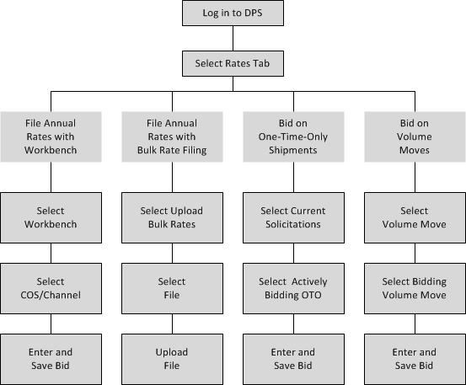
Figure 2-1. DPS Rate Filing Process Flow

Rate Filing Methods
There are several methods used to submit annual rates and daily bids. The methods used by each TSP will vary based on preference and type of shipment. Annual rate filing is conducted in two bidding rounds, while bids created in response to daily RFQs are submitted in a single round. When filing annual rates, a TSP may use both annual rate filing methods to prepare and finalize a submission:
  - Workbench. Allows rate filing for annual markets using a Web-based interface. Appropriate for a TSP filing for a single SCAC on a few channels, and for modifications to rates entered using the Upload Bulk Rates option. Rates are entered directly into a Web interface, submitted and validated.
  - Upload Bulk Rates. Used to file annual rates for multiple SCACs and multiple markets with a single file. Appropriate for a Rate Filing representative or a TSP. Submit rates in a comma separated value format (.csv, also known as a comma delimited file). An additional round of validation is applied overnight to verify channels, SCACs, formats, etc.
  - One-Time-Only (OTO). Used by a qualified TSP to bid on an OTO solicitation. Values are entered directly into a Web interface, submitted and validated. The Web interface is the only method available for responding to OTO solicitations. Rate Filing Representatives may not bid on OTO shipments on behalf of a TSP.
  - Volume Move. Allows qualified TSPs and Rate Filing Representatives to bid on Volume Moves. Values are entered directly into a Web interface, submitted and validated. The Web interface is the only method available for responding to Volume Move RFQs.

File Annual rates with Workbench
The Workbench offers a mechanism for selecting a market and channel, and entering a competitive rate for service. A Rate Filing Representative or a TSP Master may select a market, and view, enter and submit rates for peak and non-peak service during an open filing window.
NOTE: The Workbench also offers view and edit access to rates submitted using the Upload Bulk Rates option. After submitting a new bulk rate file, a user must re-set the Rates session to view the data. To re-set the Rates session, select one of the modules listed below, and then select the Rates link again to return to the Rates module. A Rate Filing Representative may select a different SCAC and then select the original SCAC to re-set the session.
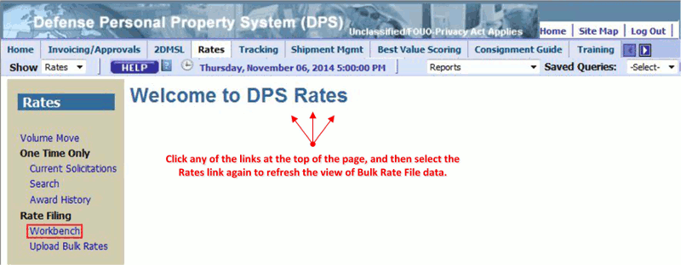
Figure 3-1: Rates Welcome Page

To re-set the session after submitting a new bulk rate file, select the Invoicing/Approvals, 2DMSL, Shipment Mgmt, Best Value Scoring or Consignment Guide tab, and then select the Rates tab.

Access the Workbench
To access the Workbench function, users log in to DPS and select the Rates tab. DPS will present the Rates Welcome Page (see Figure 3-2, below). The tabs presented near the top of the page, and the options presented in the left navigation bar, vary according to the specific user role. The illustrations in this section present the view defined for the Rate Filing Representative.
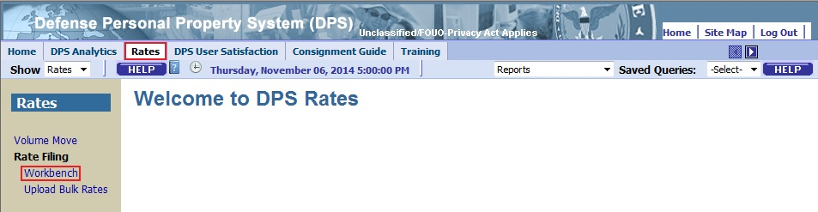
Figure 3-2. Rates Welcome Page
Select the Workbench link in the left navigation bar. DPS will present the Rate Filing Workbench page (Figure 3-3). The Workbench link is only offered when a bidding round is open.
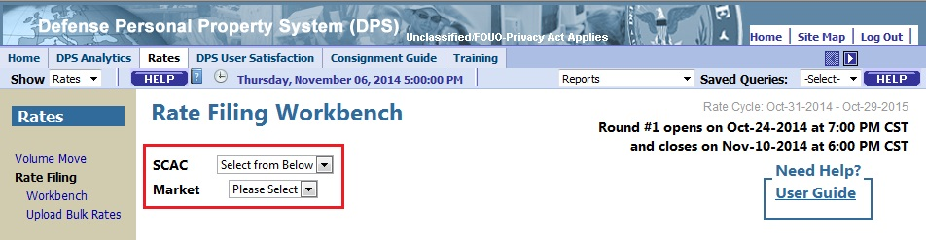
Figure 3-3. Rate Filing Workbench Page
The Rate Filing Workbench page identifies the Rate Cycle, the Round Number (1 or 2), and the open and close dates for the current rate filing round. A Rate Filing Representative must select a SCAC from a drop-down menu, while TSP users are presented with their SCAC value in read-only format.
All roles are presented with a drop-down menu used to select a market for which they are qualified.
To view channels and enter rates, select a market (e.g., dHHG, iHHG, iUB, SS iHHG, and SS iUB) from the drop-down menu. DPS will refresh the page and present associated channels (See Figure 3-4, below).
Note: If a TSP is not eligible to submit rates for the current cycle, the SCAC and Market fields are not active and the user may not proceed any further. SCAC and market options are limited to those authorized in the terms of the ETOSSS. The DUNS values set for a Rate Filing Representative determine which SCAC values are listed.
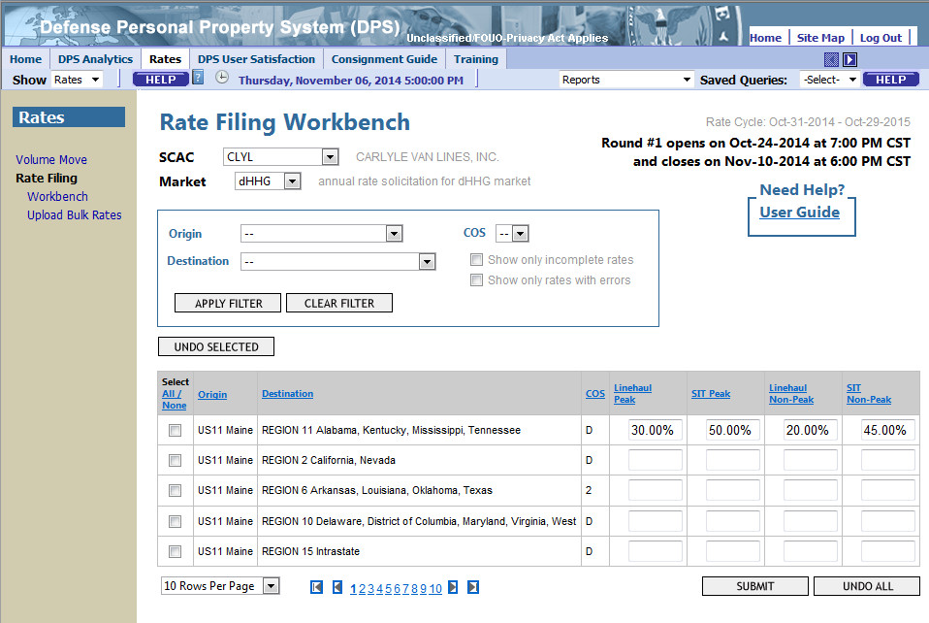
Figure 3-4. Rate Filing Workbench Page – Channel View
DPS presents channel and COS combinations for the selected market that the SCAC is qualified to bid on. Data entry fields are presented for discount rates (domestic), or single factor rates (International) for peak and non-peak Line Haul and SIT services.
To sort the listed combinations, select any of the linked column labels (Origin, Destination, COS, etc.): DPS will refresh the page and list the channels in descending order for the selected column. Select the link again to sort in ascending order.
Navigation options at the bottom of the page are used to set the number of rows presented per page (10, 25, 50 or 100) and move between pages using the numbered links or the arrow icons.
The default setting is ten rows per page; selection of another value will prompt the system to refresh the page with the selected number of rows per page, which will remain in effect when other options are used.
The arrow icons are similar to others found in DPS: the outer left and right icons, with vertical lines, are used to access the first and last pages in the range. The inner left and right arrow icons are used to move to the previous or next page. The linked numeric values offer access to a specific page of results.
Note: The User Guide link near the top of the page offers access to this document.

Filter Rate Filing Channels
To use the Rate Filing Workbench more effectively, the Filter option allows a user to limit the range of listed channel and COS combinations. Filter options also support the selection of all channels with a specific Code of Service, or limit the view to channels with incomplete rates or errors. To select criteria, use the drop-down options and check boxes below the Market drop-down menu (see Figure 3-5, below).
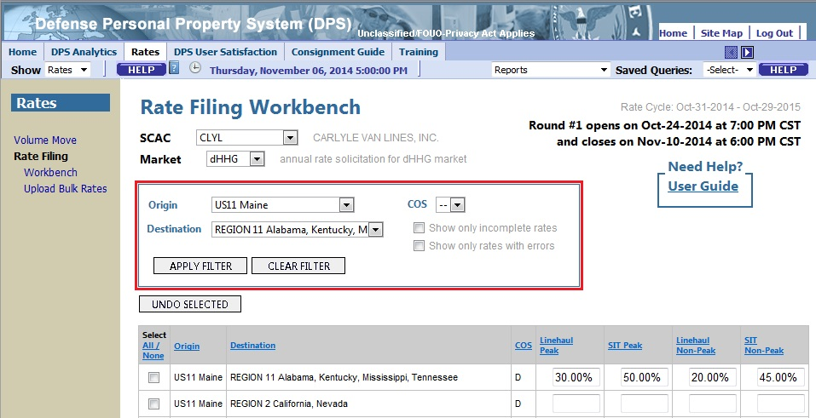
Figure 3-5. Rate Filing Workbench Page – Filter Options
In the example presented in Figure 3-5, Origin and Destination channels are selected, and the COS value is left on the default setting of All (--). Select the Apply Filter option to refresh the page and view the channel and COS combinations that match the selected criteria (see Figure 3-6, below).
Code of Service values may include the following:
- For Domestic (dHHG): D, 2
- For International Household Goods (iHHG): 4, 5, and T
- For International Unaccompanied Baggage (iUB): 7, 8, and J
- For Special Solicitation Household Goods (SS iHHG): 4, T
- For Special Solicitation Unaccompanied Baggage (SS iUB): 8
Options for Origin and Destination values are populated by the system based on which locations the SCAC is qualified to bid on.
The Filter Results view limits the channels to those matching the selected criteria.
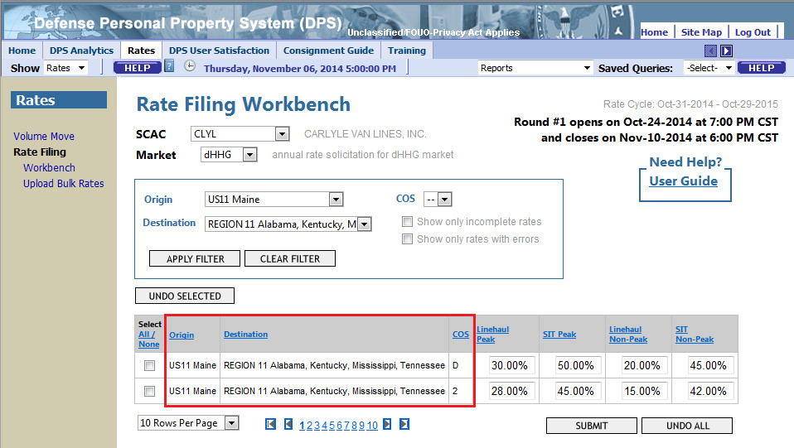
Figure 3-6. Rate Filing Workbench Page – Filter Results
In the example above, the default COS setting presents all channels, for all COS values, for the selected Origin and Destination criteria.
Note: Use the COS filter option to limit results to a single code. Use other check box options to limit results to channels with incomplete rates or errors.
The Apply Filter option supports the use of any combination of criteria: filter results by a single value or by two or more criteria (Origin, Destination, COS, only incomplete rates or only rates with errors).
To restore the original, unfiltered view, select the Clear Filter option. The page will refresh and list all channel and COS combinations for the selected market and SCAC.

Rate Entry and Submission
For a channel and COS combination listed during an open bidding round, a TSP may enter a competitive discount rate for Line Haul and SIT services, or single factor rates in peak and non-peak columns.
Rate values must conform to defined rules:
- Discount values must fall between 1.00 % and 99.00 %
- Single factor rates must fall between $1.00 and $999.00
Note: DPS will insert a % sign or a $ sign and a “.00” suffix if a whole number in entered.
A TSP may not submit a rate prior to the defined Open Date and Time for the current round.
Error messages are presented in the web interface: hover the cursor over the X presented next to a field to view a message (see Figure 3-7, below).
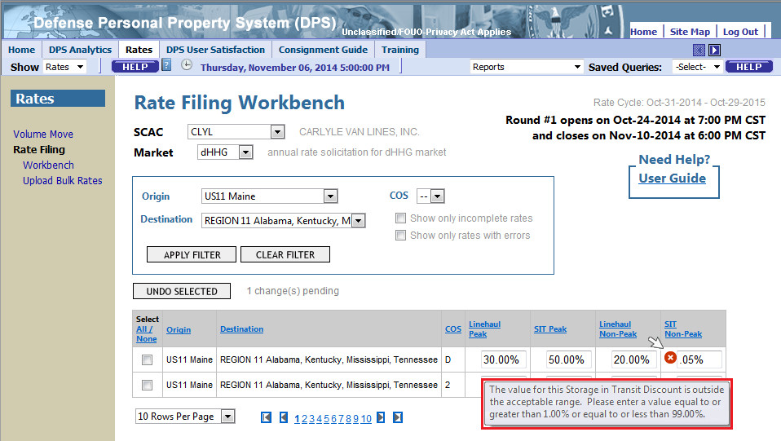
Figure 3-7. Rate Filing Workbench Page – Error Message
Note: Rate values may only include numbers and a $ sign or a % sign.
Error messages may state:
- "The value for this Line-Haul Discount is outside the acceptable range. Please enter a value equal to or greater than 1.00 % or equal to or less than 99.00 %."
- "The value for this Storage in Transit Discount is outside the acceptable range. Please enter a value equal to or greater than 1.00 % or equal to or less than 99.00 %."
- "The value for this Single Factor Rate is outside the acceptable range. Please enter a value equal to or greater than $1.00 or equal to or less than $999.00."
DPS presents green check icons to indicate acceptable entries in the rate fields (see Figure 3-8, below).
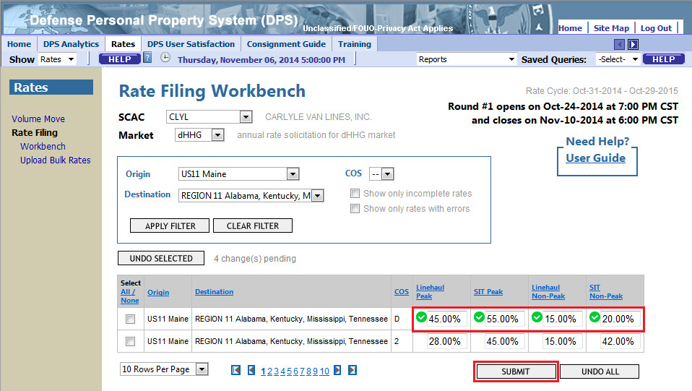
Figure 3-8. Rate Filing Workbench Page – Submit Rates
Validate content entered in all fields, and then click the Submit button to save the rate values. DPS will refresh the page and present a combination of informational messages (see Figure 3-9, below).
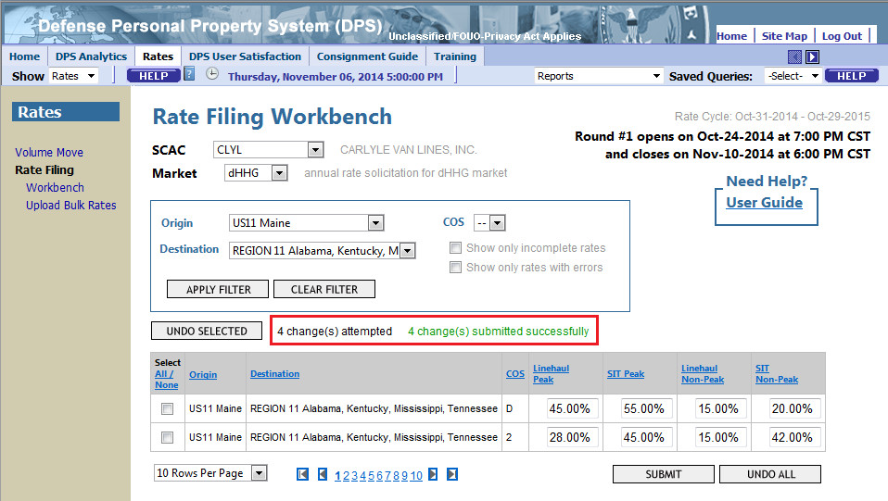
Figure 3-9. Rate Filing Workbench Page – Submission Confirmed
Note: The last rate submitted in a round overrides all previously submitted rates.

A combination of the following messages will appear above the channels listing in a rate filing session:
- “X change(s) pending” – A running count that indicates the number of rate values entered or changed since the last submit was executed. This count includes all new rates entered and any invalid rates that were not saved after the Submit was executed. The count does not change if an invalid rate is corrected, since that rate is already in the count.
- “X change(s) attempted” - Indicates the number of invalid and valid rates entered or changed. This message only appears after the submit button is clicked.
- “X change(s) failed to submit” – This message appears after the submit button is clicked and offers a sum of the rate values that contained errors. This message is cleared once a new rate is entered. To find all the rates with errors use the filter option “Show only rates with errors”.
Note: During an open round, consider the following:
- Users may submit partial channels – DPS will save values in one or more of the listed fields.
- If two users associated with the same SCAC enter rates for the same channel and COS, DPS will save the last submitted bid.
- Submit as often as possible. If a connection to the system is lost before rates are submitted, the data is lost and must be entered again.
- To delete a rate, use the backspace or delete keys to blank the rate value, and use the Submit option. DPS will not accept a zero (0) entry in a rate field; submit a blank field to delete a rate.

Round 2
In the second round of bidding, any rates accepted in the first round carry a designation of (Accepted) and are presented in read-only format (see Figure 3-10, below). A user may not delete an accepted rate.
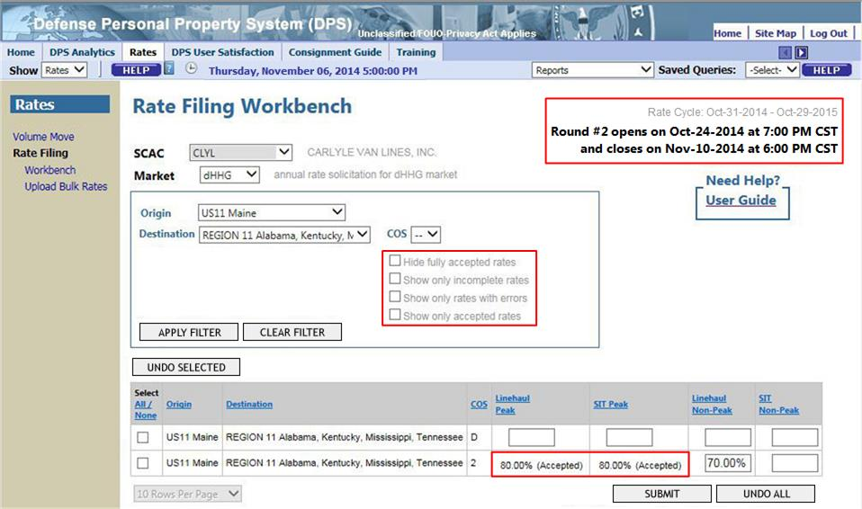
Figure 3-10. Rate Filing Workbench Page – Accepted Rates
Note the Filter options in the second round include options to hide or show accepted rates. Use these options on their own or in conjunction with the other filter options.
TSP Master and Rate Filing Representatives may enter and submit rates following the same rules in effect for Round 1 submissions (e.g., rates must fall in the acceptable range).

Undo Options
There are three options available for reversing entries prior to submission:
- Use the Select checkbox to identify one or more channels presented on the screen, and then use the Undo Selected option to reset fields to values defined in the most recent submission.
- Use the Select All option to identify all channels displayed on the screen, and then use the Undo Selected option to reset fields to values defined in the most recent submission.
- Select the Undo All option to reset all fields to values defined in the most recent submission.
DPS will prompt for confirmation of a selected Undo action prior to resetting the value defined in the most recent completed submission (see Figure 3-11, below).
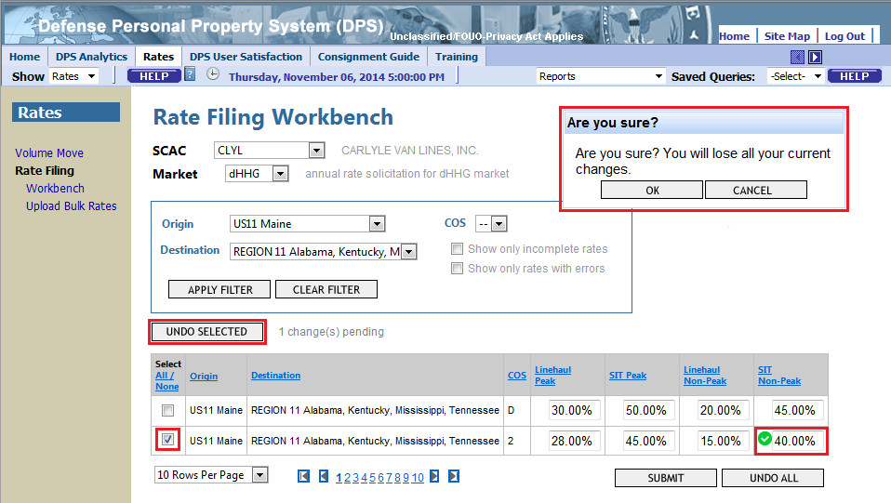
Figure 3-11. Rate Filing Workbench Page – Undo Selected
DPS will refresh the page and present values set in the most recent completed submission for the selected channel and COS.
Note: The Undo options will not set values defined in a previous submission to zero or blank, only to the most recent submitted value. To delete a defined rate, use backspace or delete to overwrite the value, and then use the Submit option.

Special Solicitation Shipments
Special Solicitation (SS) shipments are used for International markets, and include categories for Household Goods (SS iHHG) and Unaccompanied Baggage (SS iUB). To participate, a SCAC must submit bids for all channels associated with a Code of Service (COS) for a defined SS Group (e.g., all channels for a Code of Service of 4 for the Thailand SS Group).
To begin, select a Special Solicitation Market in the Rate Filing Workbench (e.g., SS iHHG). The page will refresh and present filter options specific to the market (see Figure 3-12, below). Use the filter option to limit the display to a SS Group managed in DPS (e.g., select the SS Group “Thailand,” a COS value of “4,” and then select the Apply Filter option).
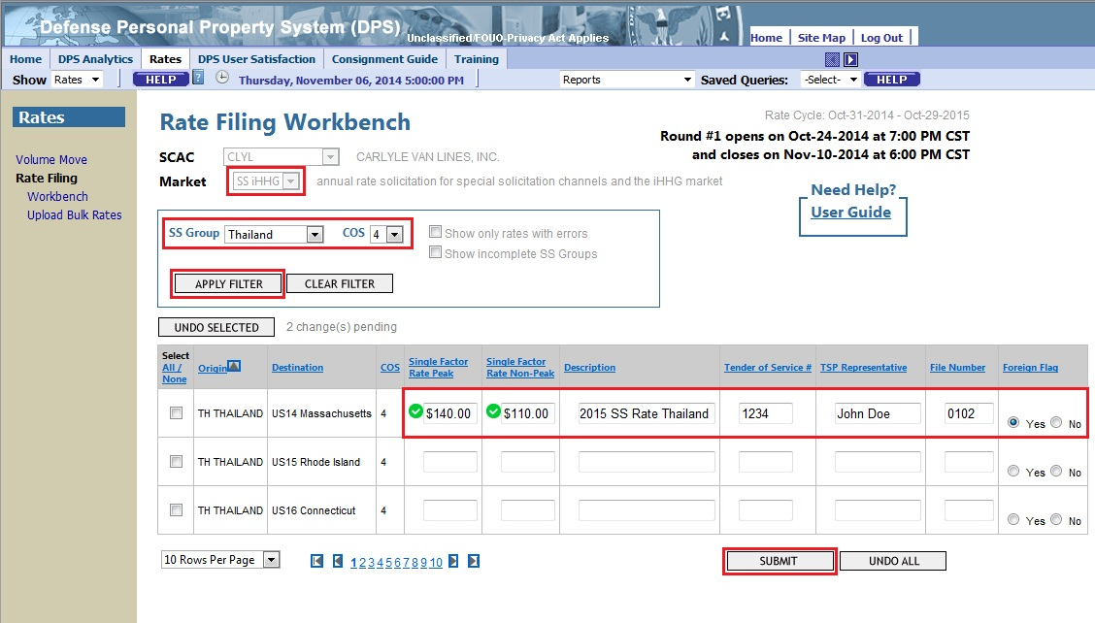
Figure 3-12. Rate Filing Workbench Page – Special Solicitation
To complete a bid for a Special Solicitation, enter Single Factor Rates, Peak and Non-Peak, for a channel. Field values for Description, Tender of Service #, TSP Representative, File Number, and Foreign Flag are optional. If an optional Tender of Service # value is entered, use the same value for all channels in a SS Group: the value is used as an identifier.
As with the standard market entries, DPS presents a green check icon for rate values that meet the defined criteria or a red “X” icon if a rate value falls outside the required criteria.
Validate content prior to using the Submit option.
The Undo options work in the same manner as they do for the standard channels: use the checkbox to select channels, and then select the Undo Selected or the Undo All option to reset rates to the values defined in the most recent submission.

Bulk Rate Filing
A TSP can file annual rates in multiple markets and a TSP Rate Filing Representative may file rates for multiple SCACs with a single bulk rate file. Bulk rate filing is not available for daily RFQs, such as One-Time-Only or Volume Move shipments.
The Bulk Rate Filing method consists of two primary steps: Prepare bulk rates and Upload bulk rates.
NOTE: Files that include non-American Standard Code for Information Interchange (ASCII) characters or hard returns will generate errors and will not process correctly.

Prepare a Bulk Rate File
Use any computer software or application that saves output in Comma Separated Value (.csv) format, Microsoft Excel, for example. Figure 4-1 offers an example of a small bulk rate file for multiple SCACs and DPS markets manifested in multiple standard solicitation RFQs.
Note: Standard Domestic, International and Special Solicitation rates are submitted in separate files.

Standard Annual Rates
Each standard bulk rate file consists of seven fields:
  - TSP SCAC
  - DPS Market identifier (“DHHG,” “IHHG,” or “IUB”)
  - Origin rate area code
  - Destination
  - For domestic – a region identifier (all must contain an explicit space)
  - For international – a rate area code
  - COS
  - Domestic Rates – Peak and Non-Peak LH discounts, as well as Peak and Non-Peak SIT discounts (percentages off rates in 400NG Tariff)
  - International Rates – a Peak and Non-Peak single factor rate (dollar amounts per 100 pounds)
Below is an example of standard rates as they appear in a spreadsheet, and as they appear in a .csv file.
Note: Before saving a .csv file, remove all column headings.
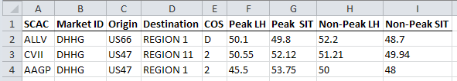

ALLV, DHHG, US66, REGION 1, D, 50.1, 49.8, 52.2, 48.7
CVII, DHHG, US47, REGION 11, 2, 50.55, 52.12, 51.21, 49.94
AAGP, DHHG, US47, REGION 1, 2, 45.5, 53.75, 50, 48
Figure 4-1. Bulk Rate File Example for Domestic Standard Solicitations
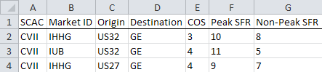

CVII, IHHG, US32, GE, 3, 10, 8
CVII, IUB, US32, GE, 4, 11, 5
CVII, IHHG, US27, GE, 4, 9, 7
Figure 4-2. Bulk Rate File Example for International Standard Solicitations

Special Solicitation Annual Rates
Each special solicitation bulk rate file consists of the same (seven) fields used with standard annual rates, plus five additional fields:
- TSP SCAC | - COS
- DPS Market (“IHHG” or “IUB”) | - Peak single factor rate
- Origin rate area code | - Non-peak single factor rate
  - Destination rate area code

  - Channel description (optional field that may have up to 200 characters)
  - Tender number (optional field that may have up to 200 characters)
  - Rate filing representative’s name (optional field that may have up to 200 characters)
  - File number (optional field for Volume Move that may have up to 200 characters)
  - Foreign flag certification code (optional field; use 1=Yes or 2=No)
Below is an example of special solicitation rates as they appear in a spreadsheet and in a .csv file.
NOTE: Before saving as a .csv file, remove the column headings.
The example in Figure 4-3 illustrates selected records of an acceptable file. Records comprising each channel group are accepted only when a rate is provided across every channel for each code of service.
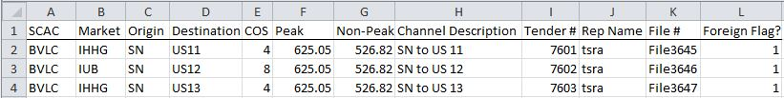
BVLC, IHHG, SN, US11, 4, 625.05, 526.82, SN to US11, 7601, tsra, 3645, 1
BVLC, IUB, SN, US12, 8, 625.05, 526.82.39, SN to US12, 7602, tsra, 3645, 1
BVLC, IHHG, SN, US13, 4, 625.05, 526.82, SN to US13, 7603, tsra, 3645, 1
Figure 4-3. Bulk Rate File Example for Special Solicitations

Data Element Information
DPS supports the upload of a comma-delimited text file. The name of the file must end with “.csv.” The file name should contain <user log in>_<year of submission>.csv. For example, adp0001_2007.cvs.
NOTE: If there is more than one file, include additional characters after the <year of submission> to help identify the individual file. For example, adp0001_2007_DHHG.cvs.
Tables 4-1, 4-2, and 4-3 describe the data elements formats for Domestic, International, and Special Solicitation files.
Table 4-1. Domestic File Format
Data Element Name | Max Length | Record Position | Required Indicator | Comments | Sample Data
SCAC | 4 | 1 | Mandatory | Four-character TSP identifier | BVLC
Market | 4 | 2 | Mandatory | Market identifier – “DHHG” | DHHG
Origin Rate Area | 10 | 3 | Mandatory | An origin rate area code | US66
Destination Rate Area | 10 | 4 | Mandatory | A region identifier | REGION 1
Code of Service | 1 | 5 | Mandatory | A Code of Service – “D” for standard domestic shipments, “2” for domestic containerized shipments | D
Peak LH Discount | 5 | 6 | Mandatory | Peak Season LH discount – percentages off the rates listed in the 400NG Tariff, from 1.00 to 99.00 | 50.50
Peak SIT Discount | 5 | 7 | Mandatory | Peak Season SIT discount – percentages off the rates listed in the 400NG Tariff from, 1.00 to 99.00 | 70.30
Non-Peak LH Discount | 5 | 8 | Mandatory | Non-Peak Season LH discount – percentages off the rates listed in the 400NG Tariff, from 1.00 to 99.00 | 50.50
Non-Peak SIT Discount | 5 | 9 | Mandatory | Non-Peak Season SIT discount – percentages off the rates listed in the 400NG Tariff from, 1.00 to 99.00 | 70.30

NOTE: In a Domestic File Format, each line must contain exactly eight (8) commas.

Table 4-2. International File Format
Data Element Name | Max Length | Record Position | Required Indicator | Comments | Sample Data
SCAC | 4 | 1 | Mandatory | Four-character TSP identifier | ALLV
Market | 4 | 2 | Mandatory | Market identifier – “IHHG” or “IUB” | IHHG
Origin Rate Area | 10 | 3 | Mandatory | An origin rate area code | US47
Destination Rate Area | 10 | 4 | Mandatory | Rate area code | AS11
Code of Service | 1 | 5 | Mandatory | A Code of Service – 7,8,J for IUB market and 4,5,T for IHHG market | 3
Peak Rate | 7 | 6 | Mandatory | A peak single factor rate – in dollars per 100 pounds, from 1.00 to 999.00 | 90.45
Non-peak Rate | 7 | 7 | Mandatory | A non-peak single factor rate – in dollars per 100 pounds, from 1.00 to 999.00 | 140.22

NOTE: In an International File Format, each line must contain exactly six (6) commas.

Table 4-3. Special Solicitation File Format
Data Element Name | Max Length | Record Position | Required Indicator | Comments | Sample Data
SCAC | 4 | 1 | Mandatory | Four-character TSP identifier | BVLC
Market | 4 | 2 | Mandatory | Market identifier – “IHHG” or “IUB” | IHHG
Origin Rate Area | 10 | 3 | Mandatory | An origin rate area code | SN
Destination Rate Area | 10 | 4 | Mandatory | A destination rate area code | US11
Code of Service | 1 | 5 | Mandatory | Code of Service – 8 for IUB market and 4 or T for IHHG market | 4
Peak Single Factor Rate | 7 | 6 | Mandatory | A peak single factor rate – in dollars per 100 pounds, from 1.00 to 999.00 | 625.05
Non-Peak Single Factor Rate | 7 | 7 | Mandatory | A non-peak single factor rate – in dollars per 100 pounds, from 1.00 to 999.00 | 526.82
Description | 200 | 8 | Optional | A description of a channel. Can be alphanumeric or blank. It cannot include commas | SN to US11
Tender Number | 200 | 9 | Optional | TSP Tender Number can be alphanumeric or blank. It cannot include commas. Value must be the same for all rates filed for the same Group and Code of Service. For example, all rates To and From Singapore for Code of Service 4 must have the same value in Tender Number | GIPU7601
Name of TSP Representative | 200 | 10 | Optional | Can be alphanumeric or blank. It cannot include commas | John Smith
File Number | 200 | 11 | Optional | TSP File Number can be alphanumeric or blank. It cannot include commas | File3645
Foreign Flag Certification | 1 | 12 | Optional | A foreign flag certification code (1=Yes/2=No). Can be alphanumeric or blank. It cannot include commas | 1

NOTE: In a Special Solicitation File Format, each line must contain exactly 11 commas.

How to Upload Bulk Rates
Access the DPS Rates page by selecting the Rates tab in the top navigation bar (see Figure 4-4, below). The following figures show the DPS interface as it is presented to a TSP Rate Filing Representative.
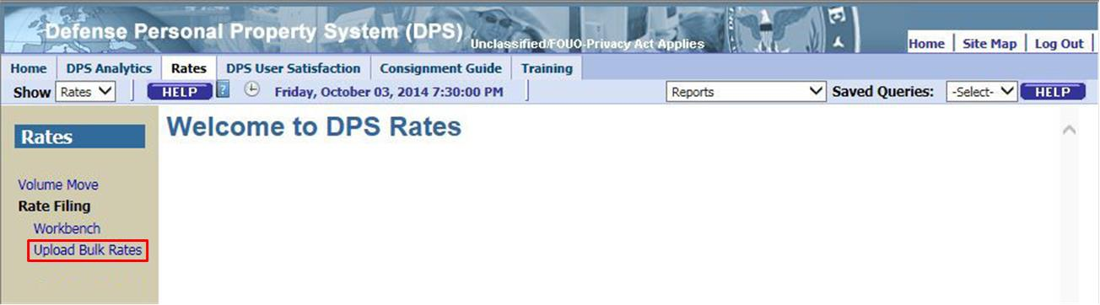
Figure 4-4. Rates Welcome Page
Select the Upload Bulk Rates link in the left navigation bar. DPS presents the Upload Bulk Rates page, which lists fields that include the Round number and bidding start and end dates (see Figure 4-5, below).
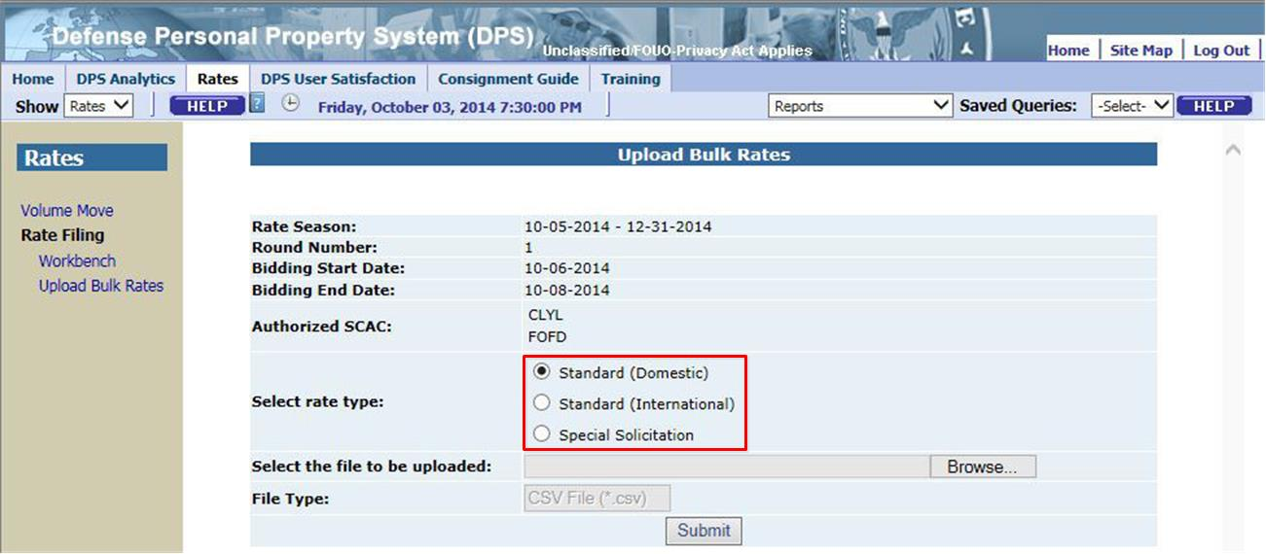
Figure 4-5. Upload Bulk Rates Page – Select Rate Type
To upload a bulk annual rate file, complete the following steps. First, select a rate type (Standard or Special Solicitation). Upload Bulk Rates accepts annual rates in a .csv file format. Select the Browse option to open the Choose File dialog box (see Figure 4-6, below).

Note: The bid start and end dates are presented in GMT, and may be different than the values presented in Workbench (which are presented in local time). If the bidding window is closed, DPS presents an error message on the Upload Bulk Rates page to warn the user that rates may not be filed at this time. Return to the page when the window is open.
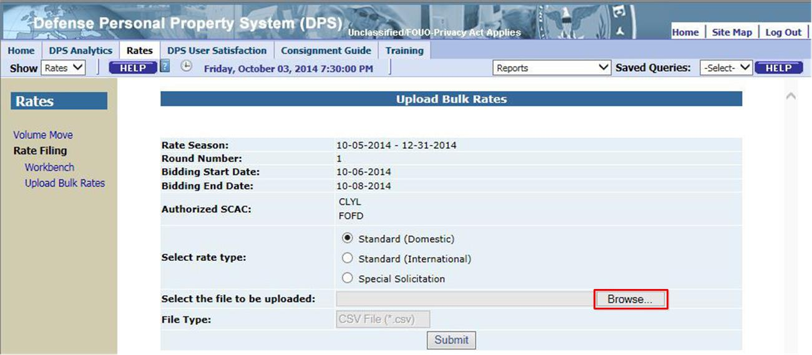
Figure 4-6. Upload Bulk Rates Page – Browse
The Windows Choose File to Upload dialog box appears and displays the computer file system. Select a rate file (.csv file) to upload. In the example in Figure 4-7, the file named adp001_2015.csv is stored on the Windows Desktop. Select the desired file: DPS will populate the file name. Select Open to continue.
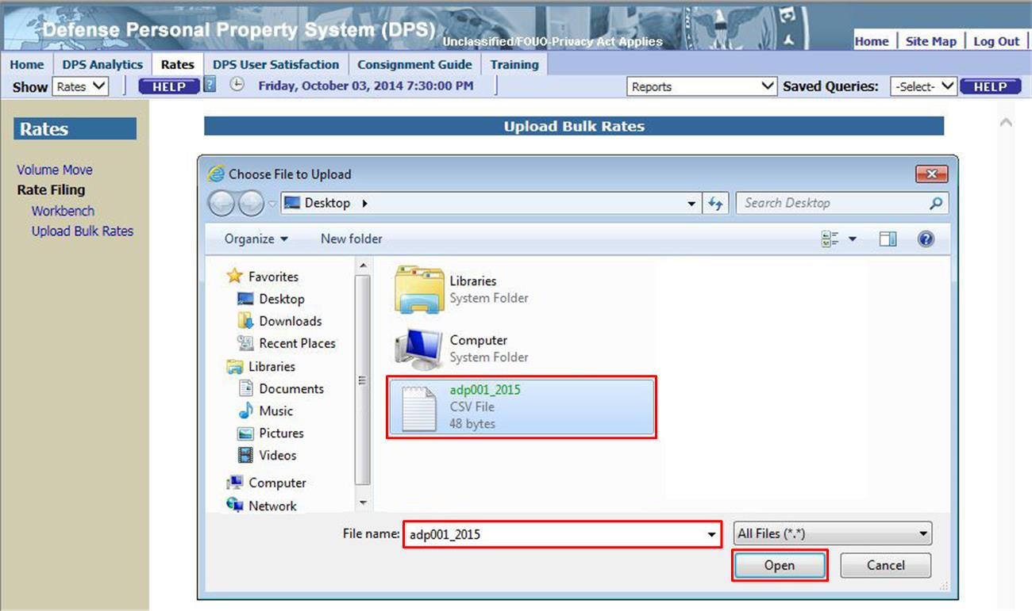
Figure 4-7. Windows Choose File Dialog Box
The Choose File to Upload dialog box closes and DPS presents the previously selected rate type, the name of the selected file, and the file type (.csv). Review the details, and then select the Submit option (see Figure 4-8, below).

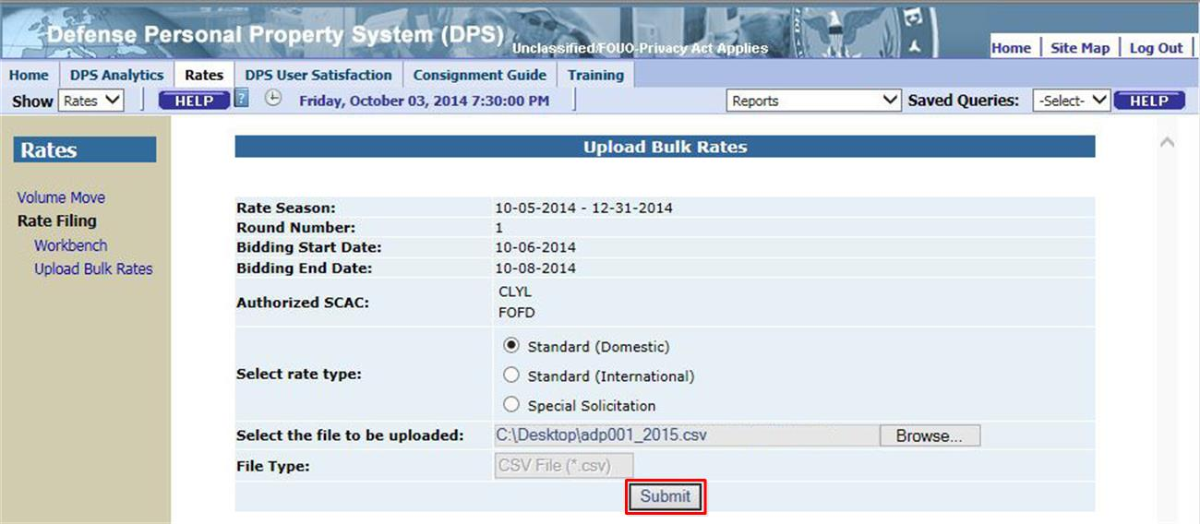
Figure 4-8. Upload Bulk Rates Page – Submit
NOTE: Users may upload bulk rate files any number of times during a bidding round. However, if some rates have been accepted and are included in another bulk rate file upload, DPS will send an email to the TSP indicating an accepted rate may not be changed.
DPS presents a confirmation message following submission of a bulk file (see Figure 4-9, below). The message indicates the name assigned to the file by the system.
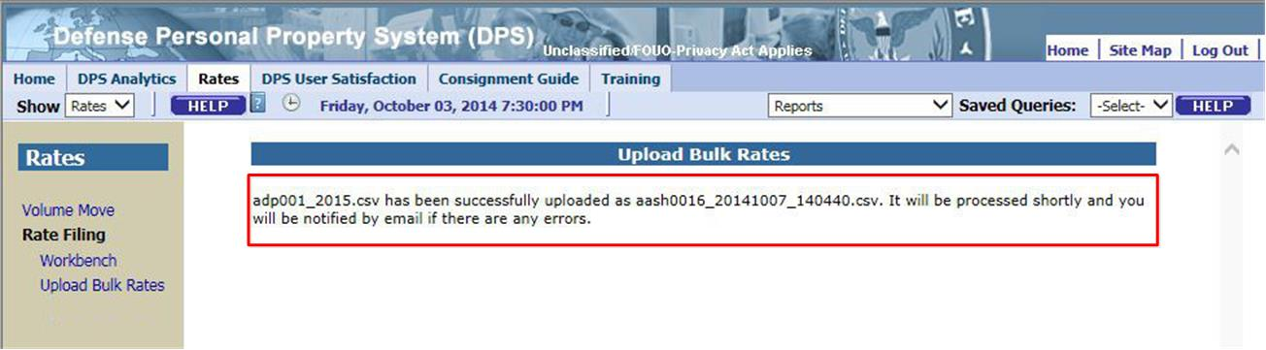
Figure 4-9. Upload Bulk Rates Page – Confirmation
Users may not resubmit a rate accepted in Round 1, unless it is part of a set of rates that were partially accepted.
For example, if all rates for a channel were accepted, resubmitting rates for that channel will result in a rejection email. If some rates on a channel were accepted, but others were rejected, ALL rates on that channel must be resubmitted. DPS will send a rejection email for rates that were previously accepted but resubmitted, and for any new rate values that generate an error.
NOTE: There are no delete options in the bulk rate interface. Use the Workbench function to overwrite a submitted value with a blank entry.

Bulk Rate Validation
Bulk rate files are validated three times:
- Immediately, upon submission
- Overnight
- At the conclusion of the current round

Immediate Onscreen Validation
Upon submission, a bulk rate file is examined to ensure:
  - It is in .csv format
  - There are no illegal characters
  - Records and fields are properly delimited
  - The correct number of fields is present on each record
A message appears confirming whether or not a bulk rates file meets these criteria. Correct and resubmit a file as many times as needed until the submission message confirms the file has uploaded successfully (see Figure 3-9, above).
NOTE: Bulk Rate Files are transferred into Workbench in the order they were submitted and successfully uploaded. If any issues are encountered, use a screen capture utility to document system responses and supplement help desk ticket content.

Overnight Validation
Overnight, a bulk rates file is examined to ensure:
  - TSP Rate Filing Representative is permitted to submit rates for all SCACs and markets
  - TSP Master is permitted to submit rates for their SCAC and the defined markets
  - TSP is approved (i.e., not in Prospective or Inactivated status)
  - Market codes are valid (are “dHHG,” “iHHG” and “iUB” only)
  - Channel origin and destination identifiers are valid and legitimate
  - There are no conflicts with (domestic) intra/interstate eligibility
  - Codes of service are valid with associated channel types
  - Rates consist of only digits and an optional decimal point (period), have no more than two decimal digits, and are within acceptable ranges (reasonableness is validated at the end of rounds)
  - Rates accepted in Round 1 should not be resubmitted, unless only parts of a set of rates for a channel were accepted. For example, if all rates for a channel were accepted, resubmitting rates for that channel will not change the rate, and will result in a rejection email for the new rate. If some rates on a channel were accepted, but others were rejected, ALL rates on that channel must be resubmitted. DPS will send a rejection email for the rates that were previously accepted but resubmitted, and for any newly submitted rates that generate an error code.
DPS sends a separate email message (see Figure 4-10) for each SCAC that does not meet all of the overnight criteria – to the respective TSP and submitter (i.e., if a rate filing representative submits the file). No email message is sent when all rates submitted for a SCAC are valid. After receiving an email message, make corrections to the bulk rates file and resubmit – DPS will send additional email messages if additional exceptions are identified.
NOTE: Some exceptions are qualifications-related and indicate discrepancies that are addressed within TSP Qualifications, possibly with SDDC or by removing records from a file.
Table 4-4 lists all exceptions associated with overnight bulk rate file validation.
Table 4-4. Bulk Rate Validation – Overnight Exceptions
Code | Description
1 | Representative cannot submit rates for this SCAC as the relationship has not been set up.
2 | TSP cannot submit rates for another SCAC.
3 | Invalid origin domestic rate area.
4 | Invalid origin international rate area.
5 | Invalid destination domestic region.
6 | Invalid destination international rate area.
7 | Invalid COS for the given market.
8 | TSP not authorized to submit rates for intrastate channels.
9 | TSP not authorized to submit rates for interstate channels.
10 | Peak LH discount outside acceptable range (1% – 99%).
11 | Peak SIT discount outside acceptable range (1% – 99%).
12 | Peak single factor rate outside acceptable range ($1 – $999).
13 | Non-peak single factor rate outside acceptable range ($1 – $999).
14 | Invalid market.
15 | TSP cannot submit the rates because the TSP was not eligible when the first bid window opened.
16 | Peak LH/Single factor rate was already accepted in Round 1.
17 | Peak LH/Single factor rate has invalid characters/numbers.
18 | Peak LH/Single factor rate contains more than two digits after the decimal point.
19 | Peak single factor rate is less than minimum acceptable value of $1.
20 | Non-peak single factor rate is less than minimum acceptable value of $1.
21 | Non-peak SIT/Single factor rate was already accepted in Round 1.
22 | Non-peak SIT/Single factor rate has invalid characters/numbers.
23 | Non-peak SIT/Single factor rate contains more than two digits after the decimal point.
24 | Nonpeak LH discount outside acceptable range (1% - 99%).
25 | Nonpeak SIT discount outside acceptable range (1% - 99%).
26 | Nonpeak LH/Single factor rate was already accepted in Round 1.
27 | Nonpeak LH/Single factor rate has invalid characters/numbers.
28 | Nonpeak LH/Single factor rate contains more than two digits after the decimal point.
29 | Peak SIT/Single factor rate was already accepted in Round 1.
30 | Peak SIT/Single factor rate has invalid characters/numbers.
31 | Peak SIT/Single factor rate contains more than two digits after the decimal
X1 | At least one data column does not exist in the record.
X2 | Internal error processing this record into Workbench.
Z1 | Invalid channel ID or invalid channel/COS combination for dHHG.
Z2 | Invalid channel ID or invalid channel/COS combination for CONUS-OCONUS.
Z3 | Invalid channel ID or invalid channel/COS combination for OCONUS-CONUS.
Z4 | Invalid channel ID or invalid channel/COS combination for OCONUS-OCONUS.

From: "rates@sddc.army.mil" <rates@sddc.army.mil>
reply-to rates@sddc.army.mil
To: tsp.email@example-tsp.com
Date: Apr 14, 2007 2:08 AM
Subject: Standard: Rate(s) Rejected
You are hereby notified that the Rate(s) submitted for the following channel and Code of Service have been rejected. See below and/or the attached file for more details.
You may resubmit the below rates again by uploading a new rates file before the end of rate filing.
Thank You.
SDDC Rates Administrator.

SCAC | Code of Service | Origin | Destination | Error CD | Error description
--------------------------------------------------------------------------------------------------------------------------------------------
SMOS | D | XXXX | REGION 5 | 3 | Invalid origin domestic rate area
SMOS | D | US49 | REGION X | 5 | Invalid destination domestic region
SMOS | 3 | US49 | REGION 7 | 7 | Invalid COS for the given market
SMOS | D | US49 | REGION 8 | 10 | Peak LH discount outside acceptable range (1% – 99%)
SMOS | D | US49 | REGION 9 | 11 | Peak SIT discount outside acceptable range (1% – 99%)
SMOS | D | US4964 | REGION 1 | 16 | Peak LH/Single factor rate was already accepted in Round 1
SMOS | D | US4964 | REGION 10 | 17 | Peak LH/Single factor rate has invalid characters/numbers
SMOS | D | US4964 | REGION 11 | 18 | Peak LH/Single factor rate contains more than two digits after the decimal point
SMOS | D | US4964 | REGION 12 | X1 | At least one data column does not exist in the record

Figure 4-10. Bulk Rates Overnight Exception Email

Validation at End of Round
At the end of a round, each file is examined to ensure:
  - No Common Financial and Administrative Control (CFAC) members previously submitted rates for any listed channel/code of service.
  - TSP represented by a SCAC is active within markets for submitted rates.
  - Both rate fields are provided for each rate.
  - Rates are reasonable under standards established for the program.
  - A rate for at least one code of service across all channels comprising a special solicitation channel group (country) is provided.
DPS sends an email message (see Figure 4-11) when a bulk rates file does not meet all required criteria at the end of each round. The email message is sent to the TSP(s) represented by the SCAC(s) and to the submitter of the file, in cases where a Rate Filing representative submits the file. No email message is sent if all validation criteria are met for a SCAC. A TSP that receives an email message after Round 1 will have the opportunity to make corrections to the file and resubmit during Round 2. Files are validated for bulk rate file criteria, and a TSP may make corrections and resubmit the file to meet “immediate” and “overnight” criteria. A TSP may not correct any exceptions reported after the conclusion of Round 2.
NOTE: Once the round has closed and the Rates Processor has run, use TSP Analytics to view channels that had all rates accepted in the previous round. All rates filed that either had at least 1 component rejected or not filed can be viewed in Workbench when the round is open.
Table 4-5 lists all exceptions reported at the end of each annual rate filing round.
Table 4-5. Annual Rate Rejection – at End of Round
Code | Description
1 | Performance score of TSP is below minimum acceptable score. (This error only occurs at the creation of an RFQ, not at the end of a round.)
2 | TSP is part of a CFAC which already submitted rate for the channel and code of service. (This error only occurs at the creation of an RFQ, not at the end of a round.)
3 | TSP is not authorized to work in the market.
4 | TSP intl-rate/dom discount is higher than acceptable high for this channel and code of service.
5 | TSP did not submit both a peak and non-peak rate for this international channel.
6 | Incomplete Special Solicitation Rates.
7 | The CIP or COR of the TSP has not been updated. (This error only occurs at the creation of an RFQ, not at the end of a round.)
8 | TSP INTL-rate/DOM-discount is lower than the acceptable low for this channel and code of service.
9 | TSP did not submit a complete set of Peak and Non-Peak Linehaul and SIT discounts for the domestic channel.

From: “rates@sddc.army.mil" <rates@sddc.army.mil>
reply-to rates@sddc.army.mil
To: tsp.email@example-tsp.com
Date: Apr 14, 2013 2:08 AM
Subject: Rate(s) Rejected for [market], Round [#]
You are hereby notified that the rate(s) submitted for the following channels and codes of service have been rejected. See below for more details.
Code of Service | Origin | Destination | Error Code | Component
------------------- | ------- | ----------- | ---------- | ---------
8 | ME | UK | 2 | Peak
8 | ME | UK | 2 | NonPeak
J | ME | UK | 5 | Peak
J | ME | UK | 2 | NonPeak
7 | AR | PO | 2 | Peak
7 | AR | PO | 2 | NonPeak
REJECTION CODES LEGEND
Error Code | Description
1 | PERFORMANCE SCORE OF TSP IS BELOW MINIMUM ACCEPTABLE SCORE
2 | TSP IS PART OF A CFAC WHICH ALREADY SUBMITTED RATE FOR THE CHANNEL AND CODE OF SERVICE.
3 | TSP IS NOT AUTHORIZED TO WORK IN THE MARKET
4 | TSP INTL-RATE/DOM-DISCOUNT IS HIGHER THAN ACCEPTABLE HIGH FOR THIS CHANNEL AND CODE OF SERVICE
5 | TSP DID NOT SUBMIT EITHER PEAK OR NON-PEAK FOR THIS INTERNATIONAL CHANNEL
6 | INCOMPLETE SPECIAL SOLICITATION RATES
7 | THE CIP OR COR OF THE TSP HAS NOT BEEN UPDATED
8 | TSP INTL-RATE/DOM-DISCOUNT IS LOWER THAN THE ACCEPTABLE LOW FOR THIS CHANNEL AND CODE OF SERVICE
9 | TSP DID NOT SUBMIT A COMPLETE SET OF PEAK AND NON-PEAK LINEHAUL AND/OR PEAK AND NON-PEAK SIT DISCOUNTS FOR THE DOMESTIC CHANNEL
Note: If any rates are rejected you must resubmit them.
Thank You.
SDDC Rates Administrator
Figure 4-11. Bulk Rates Round Exception Email

One-Time-Only Shipments

Types of One-Time-Only Shipments
There are four types of One-Time-Only (OTO) shipments: iOTO, iBOTO, BOTO, and MOTO. Each type is defined in Table 5-1, below.
Table 5-1. One-Time-Only Shipment Types
Shipment Type | Definition
iOTO | iOTO shipments are used to move household goods, unaccompanied baggage, and small boats to and from overseas locations. Household goods and unaccompanied baggage shipments are classified as iOTO when there are no standard rates on file for the channel and Code of Service. See Section 5.1.1 Boat Dimension Limits for more information on the prescribed dimensions for boats.
iBOTO | All boats greater than the dimensions prescribed for standard shipments that are shipped to or from overseas locations (including Alaska) are classified as iBOTO shipments in DPS. See Section 5.1.1 Boat Dimension Limits for more information on the prescribed dimensions for boats.
BOTO | Boats and trailers shipped to and from domestic locations are classified as BOTO shipments. All boats greater than the prescribed dimensions are moved as BOTO shipments. See Section 5.1.1 Boat Dimension Limits for more information on the prescribed dimensions for boats.
MOTO | Mobile homes shipped to and from domestic locations (including Alaska) are classified as MOTO shipments. International mobile home shipments are not processed in DPS.

Boat Dimension Limits
For a boat to qualify for shipment as part of an iOTO shipment, its length must be 14 feet or less and its width 6 feet 10 inches or less, and its height 6 feet 5 inches or less. If a boat is larger, it is classified as a BOTO shipment. BOTO shipments are used when the boat, trailer included, is over 14 feet in length, or over 6 feet 10 inches in width, or over 6 feet 5 inches in height.

Requirements
In order to participate in the following programs, a TSP must meet the following pre-requisites:
- The Department of Defense (DoD) must approve a TSP to participate in an OTO program.
- A TSP must be approved to participate in the standard international program to participate in the International OTO program.
- A TSP must be approved to participate in the International OTO program to participate in the International Boat program.
For more information on OTO pre-requisites, see the DPS TSP Qualifications module or contact SDDC.

OTO Shipment Process – A high level overview

Before an OTO shipment appears in a queue for bidding, several events must occur:
- A DoD Customer or Counselor must create an OTO shipment
- A PPSO must submit the shipment in the Shipment Management module (Route OTO)
- SDDC Rates must create a solicitation for the OTO shipment

With the solicitation window open for an OTO shipment, a TSP may:
- View the shipment in the OTO Solicitation – Active queue
- Submit, Edit, or Cancel bids for solicited OTO shipments

With the solicitation window open for an OTO shipment, SDDC Rates may:
- Review the bids while a solicitation window is open
- Remove OTO bids
- Extend the solicitation window of an OTO shipment

After the solicitation window for an OTO shipment is closed, SDDC Rates may:
- Award an OTO shipment to a TSP
- Cancel an OTO award
- Re-award an OTO shipment
- Cancel an OTO shipment before the Actual Pickup Date

TSP and SDDC Rates users may enter remarks and review current or past OTO awards.

The One Time Only Queue
The figures in this section show Rates pages presented to a TSP Master.
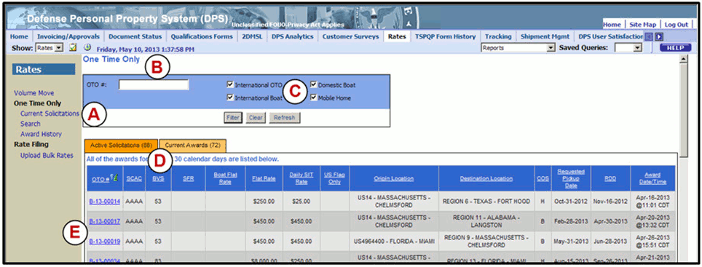
Figure 5-1. The One Time Only Queue
Figure 5-1 shows the One Time Only queue. The important elements in this queue include:
A. | A Current Solicitations link used to access the One Time Only queue. A Search link is used to access the OTO Search page, and the Award History link offers access to the Award History page.
B. | To see a specific solicitation, enter an OTO number in the OTO # field, and then select the Filter option. A blank OTO # field applies no filter, and displays all solicitations. Although wildcard characters are not permitted, truncated OTO numbers produce the following results:  Table 5-2. Example OTO Number Filters  Filter Result Returned  i- All iOTO solicitations. Likewise, a filter for “M” or “B” will present all MOTO or all BOTO solicitations, respectively.  B-13 All BOTO solicitations for 2013. A filter for X-YY, where X is the first letter of the OTO type (i, M, or B), and YY is the two-digit year, will present OTO type solicitations for a designated year.  M-13-0001 All MOTO solicitations from 2013 within the series 00010 through 00019. A filter with any number of digits in the last series will present all OTO solicitations in that series. For example “i-13-1” will list i-13-10000 through i-13-19999, but “i-13-1111” will only list i-13-11110 through i-13-11119.  i-13-12345 This is a complete OTO number, so only this shipment is returned.
C. | Check any of the boxes to include that OTO type in the search results. Select the Filter option to apply the value in the OTO # field, filter on the checkboxes, and display solicitations that match the criteria. Select Clear to reset the fields to the default (no value in the OTO #field and all boxes checked). Select Refresh to use the current filter criteria to display updated results.
D. | Select the Active Solicitations tab to access a list of OTO solicitations with an open solicitation status (i.e., shipments that a TSP may enter or edit a bid on). Select the Current Awards tab to access a list of OTO solicitations awarded to the TSP.
E. | Select any OTO number link [Ex: B-13-00014] in the OTO # column to view the Shipment.

How to Bid on a One-Time-Only Shipment
Before a solicitation appears in the One Time Only queue, it is created by a SDDC Rates user.
If any of the details of the shipment change:
- SDDC may remove all bids on that shipment
- DPS notifies TSP by email that the shipment will be re-solicited
- A TSP may re-enter a bid based on the revised solicitation
NOTE: If any details of the shipment change, including the Suspense Date/Time, an email is sent to notify TSP users of the change to allow for updates to bids. SDDC Rates may also choose to remove all bids and re-solicit a shipment. The Suspense Date/Time is the deadline for entering bids; the solicitation is awarded at any time following the deadline.
The only editable fields for an Awarded shipment are the TSP POC Info and TSP Remarks.

Bid on an OTO Solicitation
To bid on an OTO, from the One Time Only queue (Figure 5-1), enter a complete or truncated OTO number and select Filter. Except where noted, this example will use an iOTO solicitation.
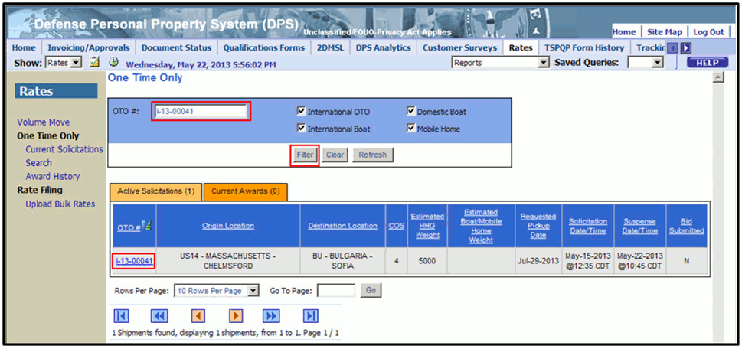
Figure 5-2. One Time Only Queue – Filtered for an iOTO
Select the OTO number link (Figure 5-2) in the Active Solicitations tab to display the Shipment Details page (Figure 5-3).
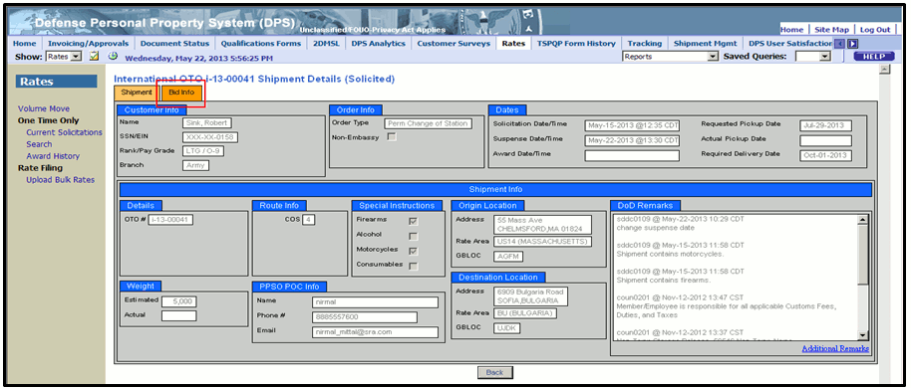
Figure 5-3. Shipment Details Page – iOTO Shipment Tab
Review information presented under the Shipment tab, and select the Bid Info tab to continue.
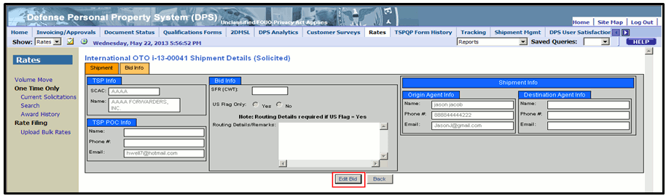
Figure 5-4. Shipment Details Page – Bid Info Tab
Select the Edit Bid option (Figure 5-4) to make the fields editable (Figure 5-5).
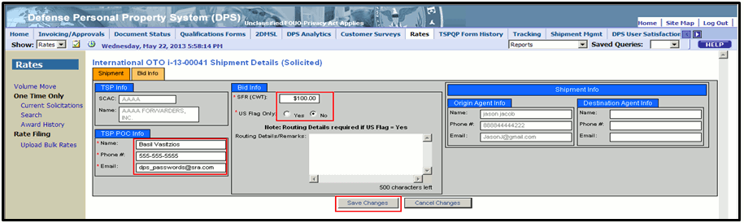
Figure 5-5. Shipment Details Page – Bid Info Tab – Enter an iOTO Bid
Enter point of contact information in the fields in the TSP POC Info area, and then enter a bid in the SFR (CWT) field. In this case, a Single Factor Rate bid is required. Indicate whether a bid is carried under US Flagged carriers exclusively, and then enter routing details. If Yes is selected for the US Flag Only question, a routing detail is required; if No is selected, the routing detail is optional.
NOTE: There are differences between bid types. BOTO and MOTO shipments, for example, require a Flat Rate instead of a Single Factor Rate, a Daily SIT Rate, and accessorial rates. iBOTO shipments also require a Boat Flat Rate. TSPs are not prompted to indicate a US Flagged carrier is used.
Figure 5-6. Shipment Details Page – Bid Info Tab – Enter a BOTO Bid
Figure 5-7. Shipment Details Page – Bid Info Tab – Enter a MOTO Bid
When satisfied with the content, select Save Changes (Figure 5-5, Figure 5-6, Figure 5-7).

Edit an OTO Bid
To edit an existing bid, follow the same steps as those listed for entering a bid. From the Shipment Details page, Bid Info tab, select Edit Bid (Figure 5-8) to make the fields editable.
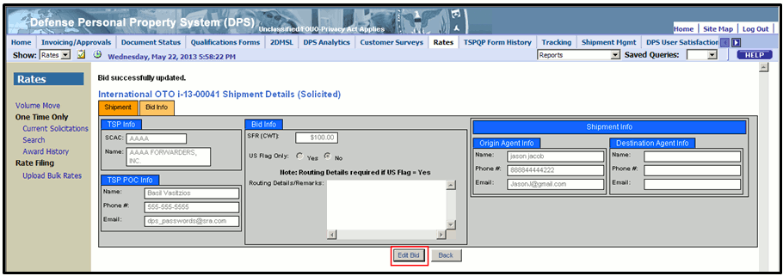
Figure 5-8. Shipment Details Page – Bid Info Tab – Bid Saved
Update information as illustrated above. In the example (Figure 5-9), the TSP POC Name and Phone #, as well as the SFR bid are changed, and the US Flag Only response is changed from No to Yes, showing how the Routing Details/Remarks field becomes a required field.
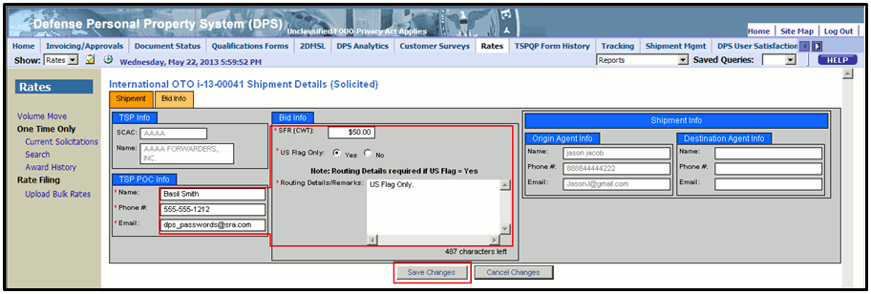
Figure 5-9. Shipment Details Page – Bid Info Tab – Edit an iOTO Bid
When satisfied with the content, select Save Changes (Figure 5-9).
Select Cancel Changes to leave the page without saving changes.

How to Review Current OTO Awards
To view the current list of OTO awards, select the Current Solicitations link in the left navigation menu, shown in Figure 5-10, and then select the Current Awards tab.
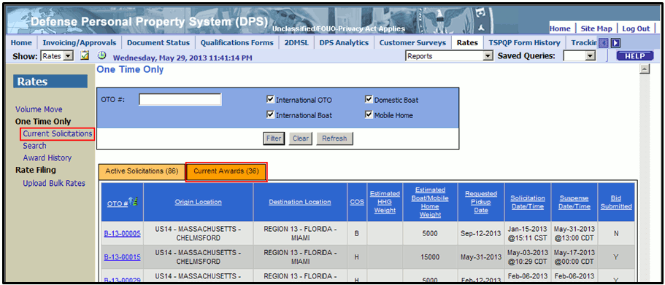
Figure 5-10. Access the Current Awards Tab
DPS presents the list of OTO shipments awarded to a TSP in the last 30 calendar days, as shown in Figure 5-11. Note this page offers access to the Shipment Details pages in the form of an OTO number link in the OTO # column of the table.
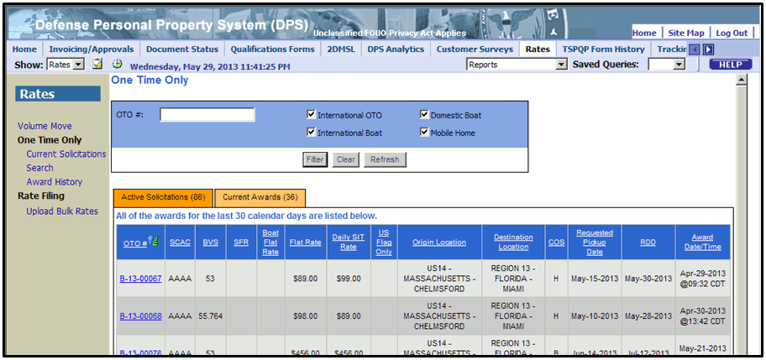
Figure 5-11. Current Awards Tab

How to Enter a Remark on an OTO Solicitation
A user may enter a remark at any point during solicitation, or after a shipment is awarded. To enter a remark, starting from the One-Time-Only queue, select an OTO number link in the OTO # column, as shown in Figure 5-12.
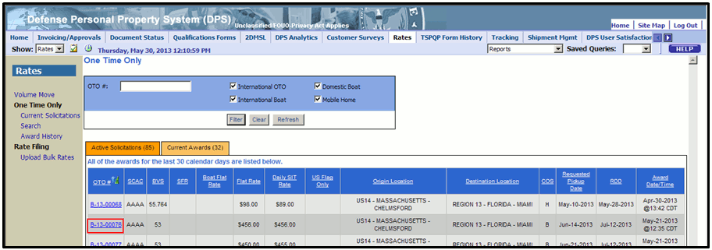
Figure 5-12. One Time Only Queue
DPS presents the Shipment Details page. In this example, there is a Domestic BOTO shipment awarded to and accepted by the TSP (Figure 5-13). Observe that the remarks field on the Shipment tab is labeled “DoD Remarks,” and is presented in read-only format.
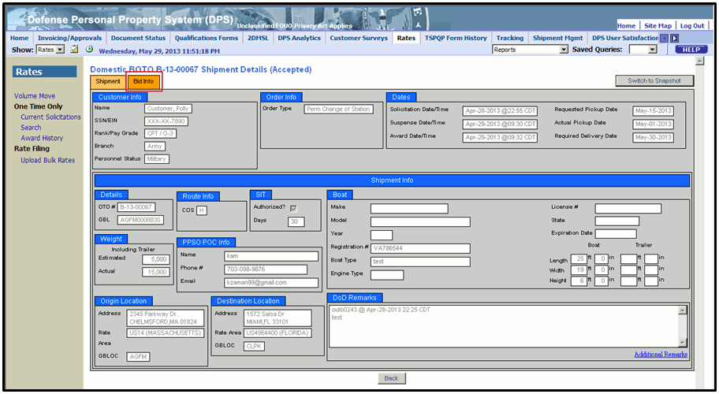
Figure 5-13. Shipment Details Page – Shipment Tab
Select the Bid Info tab to display that tab’s contents as shown in Figure 5-14.
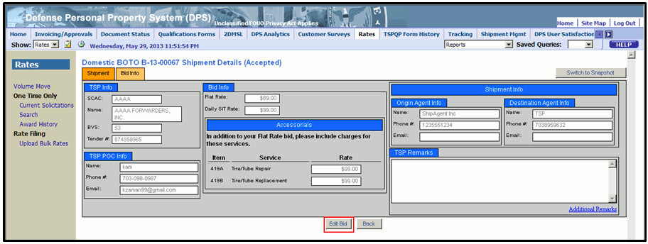
Figure 5-14. Shipment Details Page – Bid Info Tab
The remarks field on the Bid Info tab is labeled “TSP Remarks.” Before entering a remark, A TSP must place the shipment in Edit Mode. The system will present one of two dialog boxes when the Additional Remarks link is selected before placing a shipment in Edit Mode. Figure 5-15 shows the TSP Remarks dialog box when the shipment is not in Edit Mode, and there are no remarks to display.
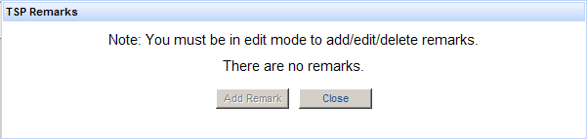
Figure 5-15. TSP Remarks Dialog Box, Not in Edit Mode, with No Previous Remarks
Figure 5-16 shows the TSP Remarks dialog box when the shipment is not in Edit Mode, and there are remarks to display.
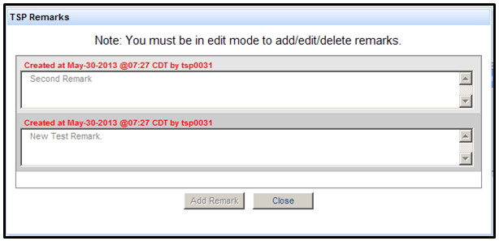
Figure 5-16. TSP Remarks Dialog Box, Not in Edit Mode, with Remarks

On the Shipment Details page, under the Bid Info tab (Figure 5-14), select Edit Bid to place the shipment in Edit Mode, as seen in Figure 5-17.
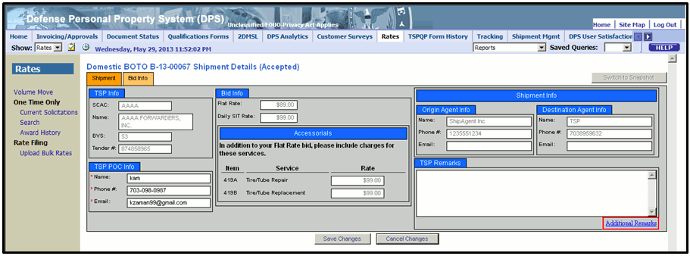
Figure 5-17. Shipment Details Page – Bid Info Tab – Edit Mode
If a shipment is in Edit mode, options are defined to Save Changes and Cancel Changes. Select the Additional Remarks link to display the TSP Remarks dialog box.
If no TSP remarks have been entered, the dialog box will display as shown in Figure 5-18
Figure 5-18. TSP Remarks Dialog Box, in Edit Mode, with No Previous Remarks
If a TSP remark has been entered previously, the dialog box will display as shown in Figure 5-19.
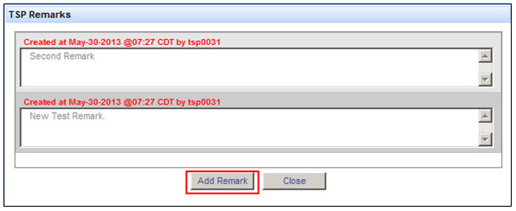
Figure 5-19. TSP Remarks Dialog Box, in Edit Mode, with Remarks
Select Add Remark to update the TSP Remarks dialog box, as shown in Figure 5-20.
Figure 5-20. Enter a TSP Remark
Enter a remark of up to 2500 characters in the New Remark field. Observe that the number of characters remaining is displayed in the lower right corner with the label “characters left.” When finished, select Save to add your remark to the TSP Remarks dialog box, as shown in Figure 5-21.
NOTE: The remark is not yet saved.
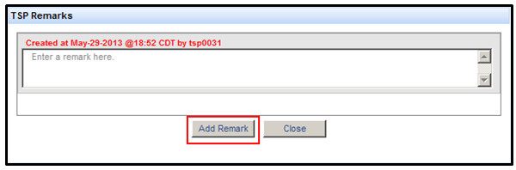
Figure 5-21. Add Another Remark or Close
Select the Add Remark or Close option. The Add Remark option presents a New Remark field, as shown in Figure 5-22. NOTE: The remark is not yet saved.
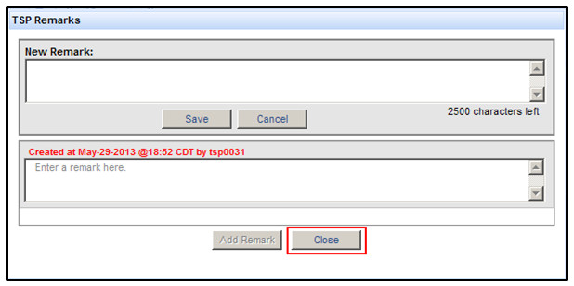
Figure 5-22. TSP Remarks Dialog Box Ready to Enter a Second Remark
For this example, after the dialog box is closed, the most recent remark is presented in the TSP Remarks field (Figure 5-23). NOTE: The remark is not yet saved.
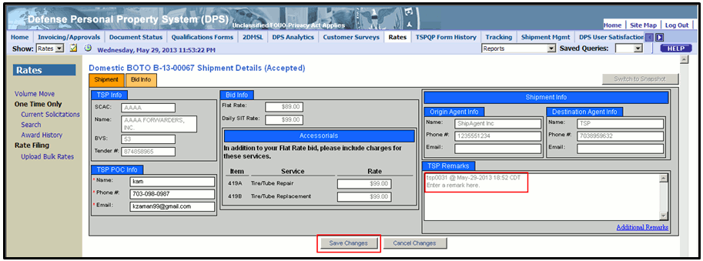
Figure 5-23. Shipment Details Page – Save or Cancel Remark
Select Save Changes to permanently add a remark to the Shipment Details for this shipment.
Select Cancel Changes to abandon a remark without saving it.

Search For An OTO Shipment
To search for an OTO shipment, access the One Time Only queue or the Search feature.
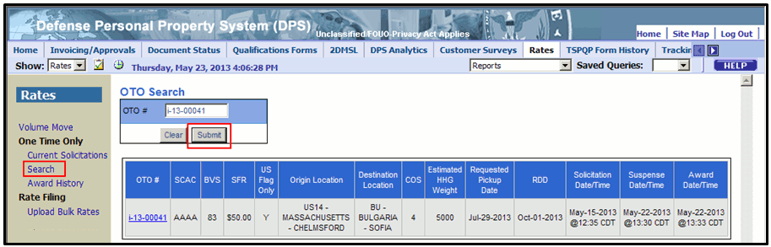
Figure 5-24. OTO Search Page
Select the Search link to Access the OTO Search page (highlighted, see Figure 5-24). The link is located under the “One Time Only” heading, in the Rates navigation pane on the left side of the DPS window.
Enter the OTO number of a shipment in the OTO # field, and then select Submit to view matching results.

Viewing the OTO Awards History page
Select the Award History link in the Rates navigation pane to view the OTO Awards History page, as shown in Figure 5-25. The OTO Awards History page presents a sortable table containing all the shipments awarded in the last 30 days (International) or 45 days (Domestic).
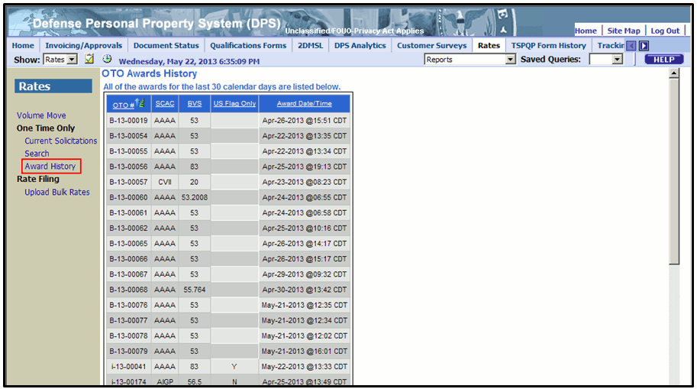
Figure 5-25. OTO Awards History Page

Volume Move
Volume Moves are a means of moving the household goods of multiple persons over the same channel. Because of the anticipated efficiencies of scale, bids for a Volume Move take the form of discounts from the standard rates for a given channel.

Volume Move Requirements

Eligibility
To bid on a Volume Move, a TSP must:
  - Have a rate on file for the applicable channel-COS combination
  - Not have any type of a punitive status (e.g., suspended, revoked, etc.) during the creation of the Volume Move solicitation
A qualified TSP is notified via email to bid on a Volume Move, which always has one bidding round and appears on the Volume Move page on the Bidding tab when solicited. The move remains visible on the tab until it is awarded.

Bid Solicitation Period
The bid solicitation period for Volume Moves is not a set period, as it is for annual rate filing. A TSP may submit Volume Move solicitations from a defined Bid Start Date/Time to a defined Bid End Date/Time.

Bid Format
Domestic Volume Move bids take the form of discounts to the accepted rates for Line Haul (LH) and Storage in Transit (SIT) for that channel. International Volume Move bids take the form of one Single Factor Rate (SFR) for the entire duration of the Volume Move.

Bid Acceptance
To receive acceptance, a Volume Move bid must be less than the standard rate a TSP has on file for the channel and code of service: i.e., offer a high discount for domestic shipments or a lower single factor rate for international shipments. A TSP must affirm that it can pick up the minimum number of pounds per day defined for the Volume Move.
A SDDC Rates user can award a Volume Move to more than one TSP, and although there is only one bidding round, there are two selection phases within the awarding process. Volume Moves in the process of bidding are listed in the Bidding tab, and appear with a Status of “Bidding.” Volume Moves are identified by Volume Move Number.

Email Notification
Email notifications are sent to each TSP selected for a contingent primary or secondary award. Only one TSP can receive a contingent primary award. If contingent secondary awards are made, they are offered to one or more TSPs.

Volume Move Page Tabbed Interface
The Volume Move page presents content under three tabs: Bidding, Accepted, and Closed. The Bidding tab contains Volume Moves which a TSP/SCAC is qualified to bid on, are available for bid, or those for which bidding has closed, but have not been processed. The Accepted tab contains Volume Moves a TSP will participate in. The Closed tab contains Volume Moves a TSP participated in that are now finished.

Volume Move Details Page Tabbed Interface
The Volume Move Details page displays data on a Volume Move under two tabs. One tab is labeled Volume Move Detailed Information and the other tab is labeled Bid Information.
The Volume Move Detailed Information tab contains information on a single Volume Move, such as start and end dates, origin and destination including Government Bill of Lading Office Codes (GBLOCs) and rate areas, rate cycle, shipment route, COS, program type, point of contact at the origin, solicitation start and end dates, and remarks.
The Bid Information tab contains TSP information, point of contact, bid data, tender number, and, if accepted or closed, bidding results information.
Select the Back option under these tabs to return to the Volume Move page without saving any changes.
Select the Back option from the Volume Move Details – Edit Bid page to return to the Volume Move Details page on the Bid Information tab without saving any changes.

How to Bid on a Volume Move
DPS allows a qualified TSP to view and bid on Volume Moves. To bid on a Volume Move, complete the following steps. Select the Rates tab, and then select the Volume Move link in the Rates menu on the Rates Welcome page (Figure 6-1).
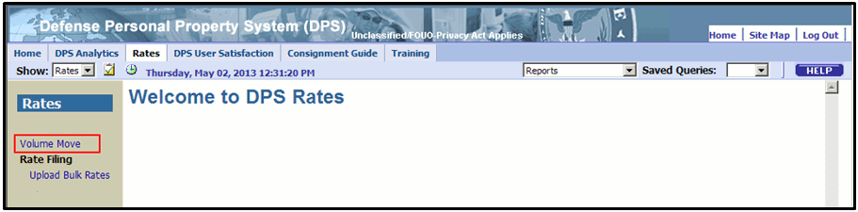
Figure 6-1. Rates Welcome Page
DPS presents the Volume Move page, which lists any available Volume Moves. A TSP Rate Filing Representative must select a value from the Select a SCAC list in order to view data (Figure 6-2).
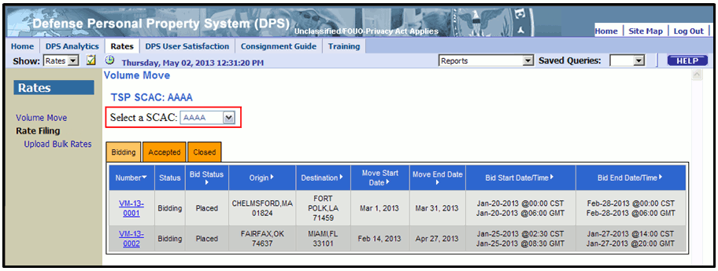
Figure 6-2. Volume Move – Select a SCAC
Select a Volume Move Number with a status of Bidding to open that Volume Move (Figure 6-3).
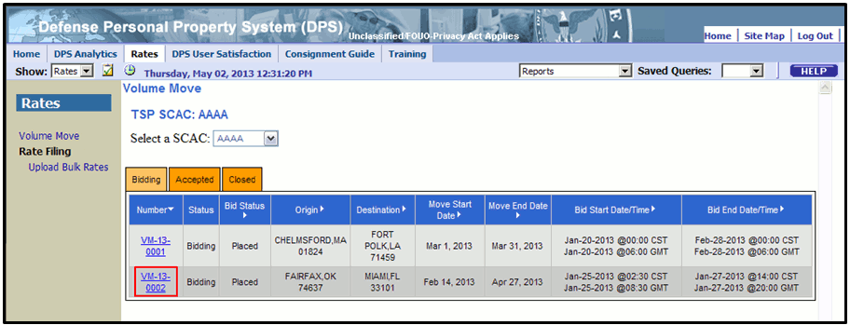
Figure 6-3. Volume Move – Select a Volume Move Number
The Volume Move Details page appears (Figure 6-4) and displays the Volume Move Detailed Information tab. Review all pertinent data on the Volume Move Detailed Information tab, and then select the Bid Information tab.
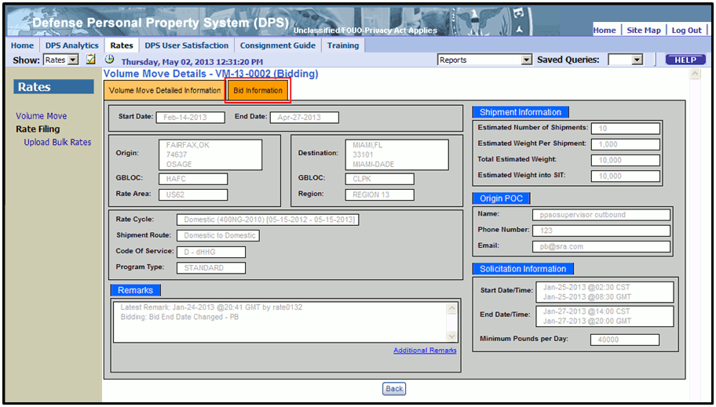
Figure 6-4. Volume Move Details Page
The Volume Move Details page now displays the Bid Details tab. Complete all required fields, and then select the Place Bid option as seen in Figure 6-5, below.
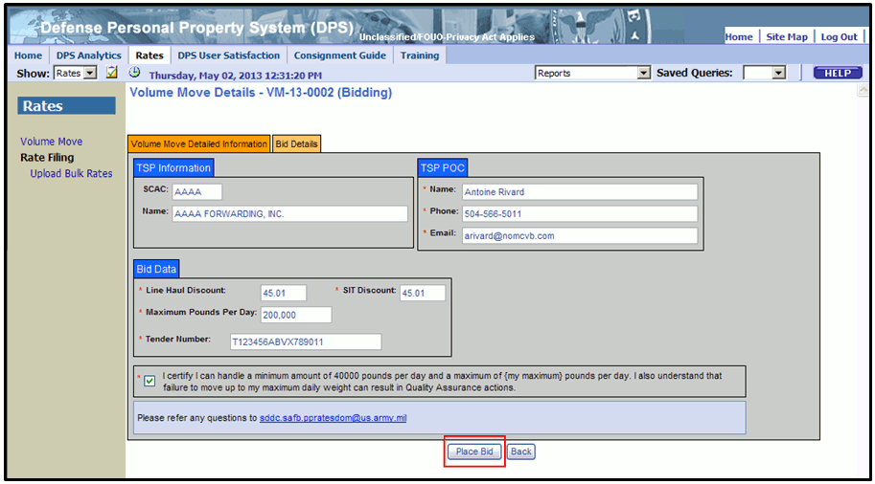
Figure 6-5. Volume Move Details Page – Place a Bid

How to Edit a Bid on a Volume Move
NOTE: A user may only edit a bid during the bidding window, which is defined by the Start Date/Time and End Date/Time values. Volume Moves are displayed in the Bidding tab on the Volume Move page until they are awarded. Therefore, not every Volume Move listed on the Volume Move page under the Bidding tab is available for editing.
DPS allows edits to bids for Volume Moves while the bidding window is open. To edit a bid, complete the following steps.
On the Rates tab, select the Volume Move link on the Rates menu (Figure 6-6).
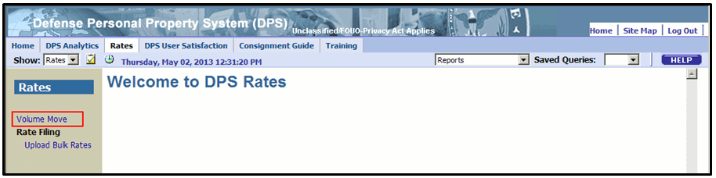
Figure 6-6. Rates Welcome Page
DPS presents the Volume Move page. Rate Filing representatives must select a value from the Select a SCAC list in order to view data (Figure 6-7).
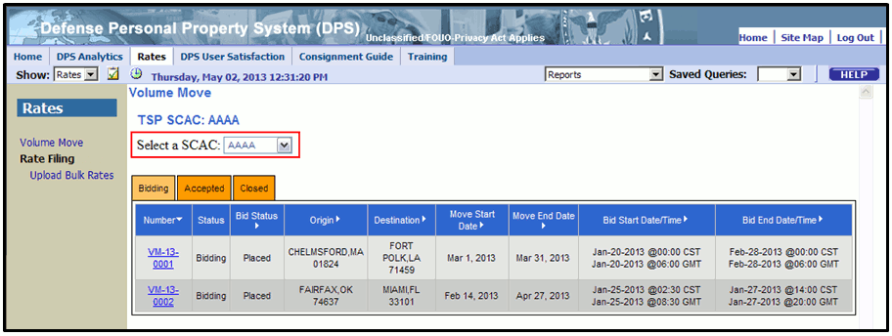
Figure 6-7. Volume Move – Select a SCAC
Select a Volume Move Number with a status of Bidding to open that Volume Move (Figure 6-8).
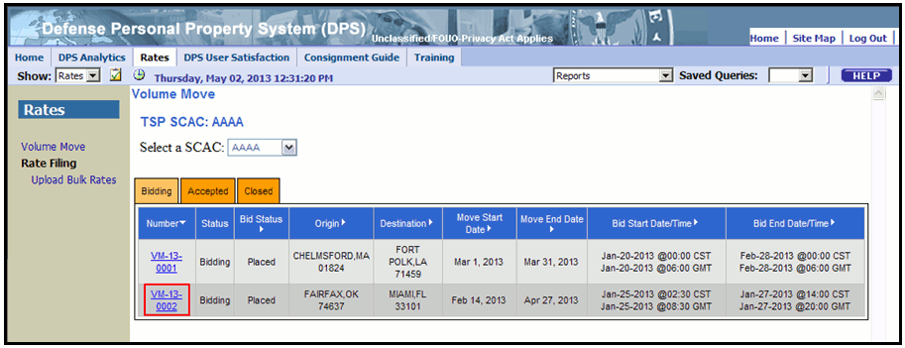
Figure 6-8. Volume Move – Select a Volume Move Number
DPS presents the Volume Move Details page and displays the Volume Move Detailed Information tab. Review all pertinent data on the Volume Move Detailed Information tab, and then select the Bid Information tab (Figure 6-9).
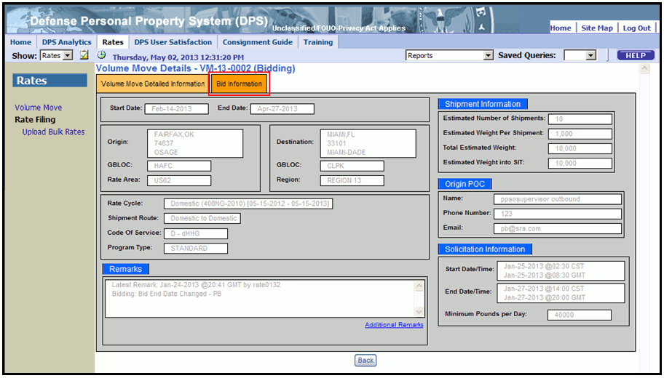
Figure 6-9. Volume Move Details Page
DPS will present the Bid Details tab. Select the Edit Bid option to continue (Figure 6-10).
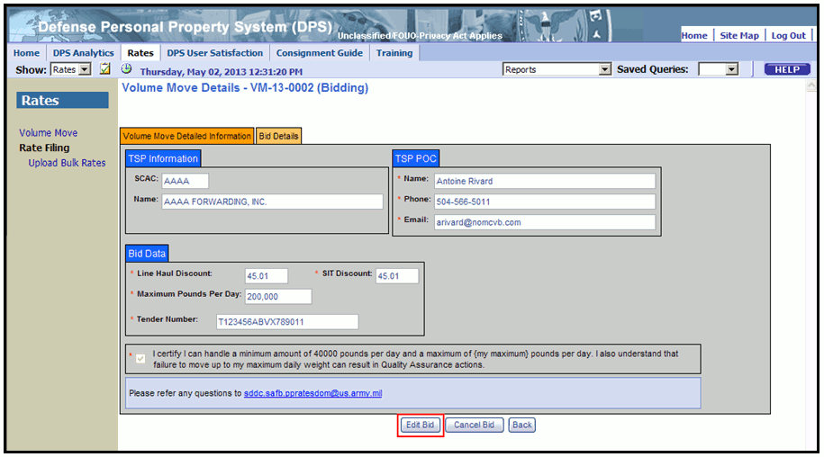
Figure 6-10. Volume Move Details Page – Bid Details Tab
DPS presents the Volume Move Details – Edit Bid page (Figure 6-11) with the bid information. Edit bid data, and then select the Save option to update the value.
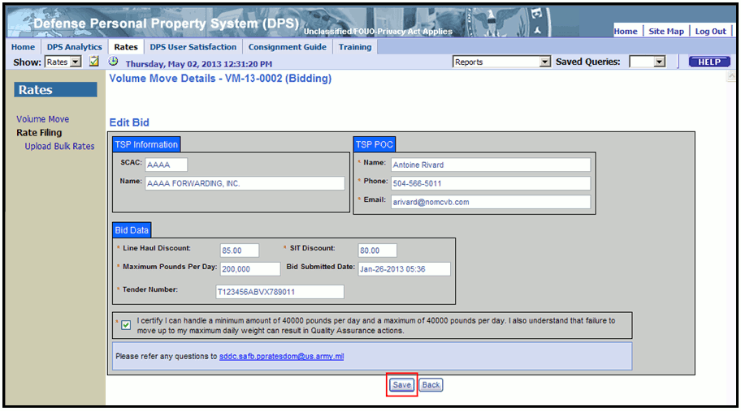
Figure 6-11. Volume Move – Edit Bid Page

How to Cancel a Bid on a Volume Move
NOTE: A user may only cancel a bid if it is in a status of “Bidding” on the Volume Move page.
To delete a bid on a Volume Move, complete the following steps. On the Rates tab, select the Volume Move link on the Rates menu (Figure 6-12).
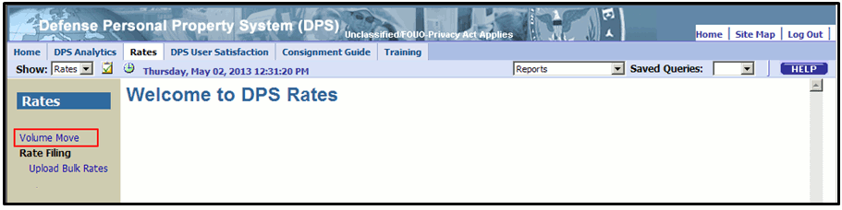
Figure 6-12. Rates Welcome Page
DPS presents the Volume Move page (Figure 6-13), which lists available Volume Moves.
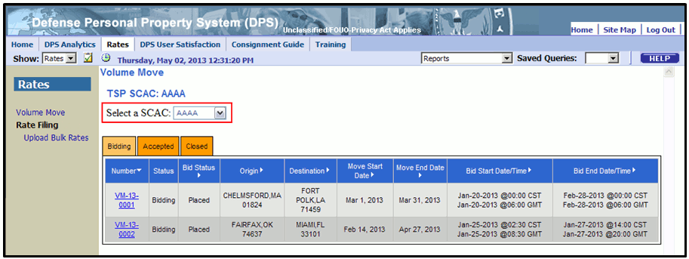
Figure 6-13. Volume Move – Select a SCAC
Rate Filing Representatives Select a SCAC in order to view data (Figure 6-13).
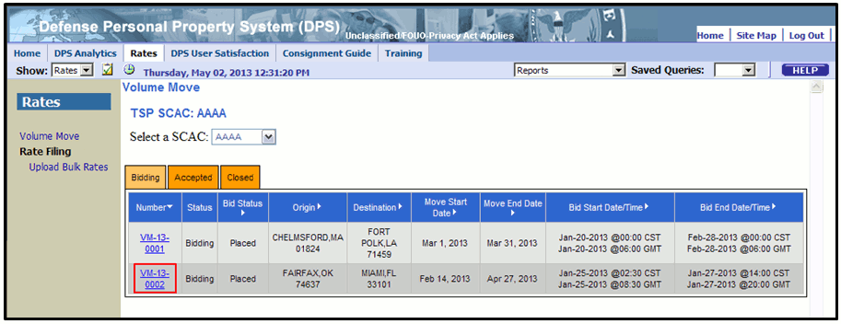
Figure 6-14. Volume Move – Select a Number
Select the Number of a bid to open a Volume Move (Figure 6-14). DPS presents the Volume Move Details page (Figure 6-15) and displays the Volume Move Detailed Information tab.
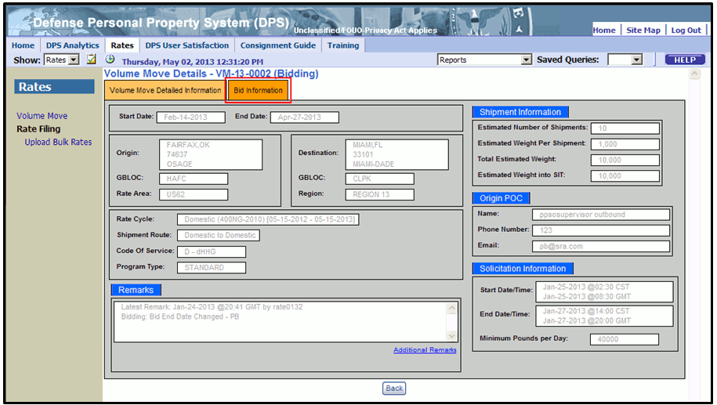
Figure 6-15. Volume Move Details Page
Review data on the Volume Move Detailed Information tab, and then select the Bid Information tab (Figure 6-15). DPS presents the Bid Details tab as shown in Figure 6-16. Select the Cancel Bid option.
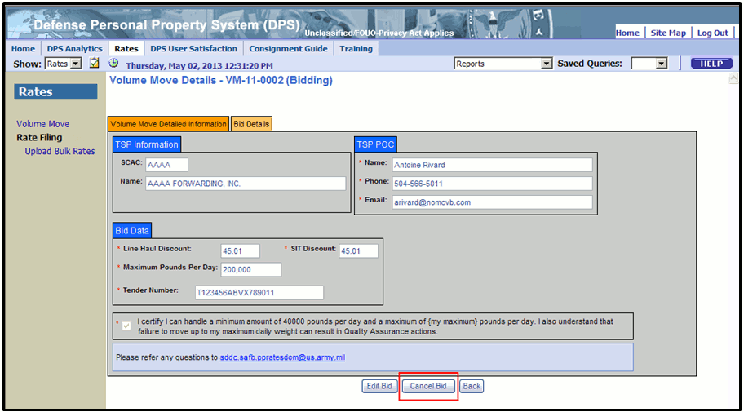
Figure 6-16. Volume Move – Cancel Bid

DPS presents the Cancel Bid dialog box (Figure 6-17). Select the Yes option to confirm cancellation.
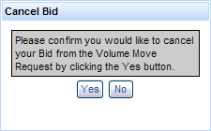
Figure 6-17. Volume Move Bid Cancellation Confirmation
Volume Moves are removed from bidding status at the conclusion of the bidding round and email notifications are sent to each TSP selected for a contingent primary or secondary award. Only one TSP may receive a primary award. More than one TSP may receive a secondary award.
DPS saves the tender number to indicate acceptance of a Volume Move award. A TSP may return to the Volume Move Details page to change or remove a tender number during the 48-hour period following notification to provide a tender number. After 48-hours have elapsed, respondents are ranked and notified, if selected as a primary or an alternate TSP.
The only scenario that may change an award level is if the TSP with a primary contingent award does not respond within 48-hours. In this case, the highest ranked secondary TSP will receive the primary award.

Appendix A: Acronyms and Abbreviations
Acronym | Definition
ASCII | American Standard Code for Information Interchange; standard text file format
BOTO | Domestic Boat One-Time-Only Shipment
COS | Code of Service
COTS | Commercial Off-the-Shelf
.csv | Comma Separated Values (file extension)
dHHG | Domestic Household Goods
DCN | Document Control Number
DoD | Department of Defense
DP3 | Defense Personal Property Program
DPS | Defense Personal Property System
ETA | Electronic Transportation Acquisition
GBLOC | Government Bill of Lading Office Code
HHGS | Household Goods
iBOTO | International Boat One-Time-Only Shipment
iHHG | International Household Goods
iOTO | International One-Time-Only Shipment
iUB | International Unaccompanied Baggage
LH | Line haul
MOTO | Mobile Home One-Time-Only Shipment
OTO | One-Time-Only Shipment
PEO-T | Program Executive Office - Transcom
RFQ | Request for Quote
SCAC | Standard Carrier Alpha Code
SDDC | Surface Deployment and Distribution Command
SFR | Single Factor Rate
SIT | Storage-in-Transit
SS | Special Solicitation
SS-iHHG | Special Solicitation International Household Goods
SS-iUB | Special Solicitation International Unaccompanied Baggage
TSP | Transportation Service Provider
VM | Volume Move
.xls | Microsoft Excel® (file extension)

Appendix B: TSP Email Notifications (Rates Module)
Email notifications are generated to TSPs during annual rate filing and to TSP, SDDC and PPSO users related to specific actions associated with the volume move and One Time Only process. This section of the guide provides the content of each type of email for the TSP user.

The Email Actions table identifies the event (action) that generates email notifications to TSP users during the Annual Rate Filing, Volume Move or One Time Only process in DPS.
Email Actions
Annual Rate Filing | Volume Move | One Time Only
Rate Rejection Notification | Volume Move Solicitation | MOTO Invitation
CFAC Error | Edit VM Bid End Date | BOTO Invitation
Special Solicitation Error | Edit VM End Date (Accepted Status) | Edit OTO Before Award
Special Solicitation Error (Final) | Cancel VM in Bidding Status | Edit Awarded OTO (w/o GBL)
 | Rejected Bid for VM | Edit Awarded OTO (w/GBL)
 | Reinstate TSP for VM Solicitation | Revised OTO SFR Rate
 | Accept Volume Move Bid | Revised OTO Boat Flat Rate
 |  | Revised OTO Flat Rate
 |  | Return OTO to Submitted Status
 |  | Remove All OTO Bids
 |  | OTO Award
 |  | OTO Pullback
 |  | Cancel OTO Shipment

The Email Notifications – TSP table below displays email content associated with an Annual Rate Filing, VM or One Time Only event (action) and the intended recipient of the email notifications.
Email Notifications - TSP
Event | Email Content | Recipient
Rate Rejection Notification | From: rates@dpsmail.sddc.army.mil  Reply To: rates@dpsmail.sddc.army.mil  To: <carrier email>  Subject: Rate(s) Rejected for <RFQ>, Round 1 (SCAC)  Message body: You are hereby notified that the rate(s) submitted for the following channel and code of service has been rejected. See below for more details.  <code of service> <channel origin> <channel dest> <rejection code>  You may resubmit your rate(s) in round 2/final round of rate filing beginning on <round 2 start date>  Note: The 2nd round is the final round of rate filing, rates rejected in the final round cannot be re-filed for any reason  Rejection codes legend  <rejection code> <rejection description>  Thank you,  SDDC Rates Administrator | TSP Master  TSP Rate Filing Agent  Refer to Appendix B for Rejection Code Legend
CFAC Error | From: rates@dpsmail.sddc.army.mil  Reply To: rates@dpsmail.sddc.army.mil  To: <carrier email>  Subject: Rate(s) Rejected for <RFQ>, Round 1 (SCAC)  Message body: You are hereby notified that the rate(s) submitted for the following channel and code of service has been rejected. See below for more details.  <code of service> <channel origin> <channel destination> <rejection code>  Rejection codes legend  <rejection code> <rejection description>  Thank you,  SDDC Rates Administrator  * Rejection Description - There cannot be two submissions from members of a Common Financial and/or Administrative Control (CFAC) group within the same international channel. If there are multiple submissions, all the submissions are rejected. | TSP Master  TSP Rate Filing Agent  Refer to Appendix B for Rejection Code Legend
Special Solicitation Error | From: rates@dpsmail.sddc.army.mil  Reply To: rates@dpsmail.sddc.army.mil  To: <carrier email>  Subject: Rate(s) Rejected for <RFQ>, Round 1 (SCAC)  You are hereby notified that the rate(s) submitted for the following channel and code of service has been rejected. See below for more details.  <code of service> < origin> <destination> <rejection code>  You may resubmit your rates(s) in round 2/final round of the rate filing beginning [round 2 start date]  Note: The 2nd round is the final round of rate filing; rates rejected in the final round cannot be re-filed for any reason.  Rejection codes legend  [rejection code] [rejection description]  Thank you,  SDDC Rates Administrator  * Rejection description - Your average filed rate is not within the RR range | TSP Master  TSP Rate Filing Agent  Refer to Appendix B for Rejection Code Legend
Special Solicitation Error - Final | From: rates@dpsmail.sddc.army.mil  Reply To: rates@dpsmail.sddc.army.mil  To: <carrier email>  Subject: Rate(s) Rejected for <RFQ>, Round 2 (SCAC)  You are hereby notified that the rate(s) submitted for the following channel and code of service has been rejected. See below for more details.  <code of service> < origin> <destination> <rejection code>  Rejection codes legend  [rejection code] [rejection description]  Thank you,  SDDC Rates Administrator  * Rejection description - Rates must be submitted from all CONUS Origin rate areas to the OCONUS Destination location and from the OCONUS Origin location to all CONUS Destination rate areas. | TSP Master  TSP Rate Filing Agent  Refer to Appendix B for Rejection Code Legend
Volume Move Solicitation | From: rates@dpsmail.sddc.army.mil  Subject: Volume Move Solicitation VM –XXX-XXXX  To: <carrier email>  The Volume Move Solicitation below is available for bidding. Please login to DPS if you wish to participate.  Rate Cycle  Shipment Route  Program Type  Origin City/State/Country  Origin GBLOC  Destination City/State/Country  Destination GBLOC  Origin Rate Area  Code of Service  Estimated # of Shipments  Estimated Weight per Shipment  Total Estimated Weight  Estimated Weight into SIT  Volume Move Start Date  Volume Move End Date  Bid Start Date/Time (CST/CDT)  Bid Start Date/Time (GMT)  Bid End Date/Time (CST/CDT)  Bid End Date/Time (GMT)  Minimum Pounds per Day  Remarks  Please Note: Your bids must be lower (higher discount or lower SFR) than YOUR current rate on file for the same channel – code of service. | TSP Master  TSP Operations  TSP Rate Filing Rep
Edit VM Bid End Date | From: rates@dpsmail.sddc.army.mil  Subject: Volume Move Request: VM-XXX-XXXX  To: <carrier email>  The Volume Move Bid End Date and/or Time has been changed. Please login to DPS to view the changes.  Shipment Route  Program Type  Origin Rate Area  Destination Rate Area  Code of Service  Estimated # of Shipments  Estimated Weight per Shipment  Total Estimated Weight  Estimated Weight into SIT  Origin City/State/Country  Origin GBLOC  Destination City/State/Country  Destination GBLOC  Volume Move Start Date  Volume Move End Date  Bid Start Time (CST/CDT)  Bid Start Date (GMT)  Bid End Date/Time (CST/CDT)  Bid End Date/Time (GMT)  Minimum Pounds per Day  Rate Cycle | TSP Master  TSP Operations
Edit VM End Date: Accepted Status | From: rates@dpsmail.sddc.army.mil  Subject: Volume Move Request: VM-XXX-XXXX  To: <carrier email>  The end date for the Volume Move Identified below has been modified.  Volume Move Number  Origin City/State/Country  Destination City/State/Country  Volume Move Start Date  Previous Volume Move End Date  New Volume Move End Date  Remarks | TSP Master  TSP Operations  TSP Rate Filing Rep*  *If they filed rates for the TSP
Cancel VM in Bidding Status | From: rates@dpsmail.sddc.army.mil  Subject: Canceled Volume Move Request: VM-XXX-XXXX  To: <carrier email>  Shipment Route  Origin City/State/Country  Destination City/State/Country  Volume Move Start Date  Volume Move End Date  Contact SDDC at sddc.safb.ppratesdom@us.army.mil with any questions. | TSP Master  TSP Operations  TSP Rate Filing Rep
Rejected Bid for VM | From: rates@dpsmail.sddc.army.mil  Subject: Rejection of (TSP Name) and (SCAC) participation in Volume Move, VM –XXX-XXXX  To: <carrier email>  You have been rejected from Volume Move VM-XXX-XXXX. If you have any questions please contact SDDC at sddc.safb.ppratesdom@us.army.mil. | TSP Master  TSP Operations
Reinstate TSP for VM | From: rates@dpsmail.sddc.army.mil  Subject: Reinstatement of (TSP Name) and (SCAC) participation in Volume Move, VM –XXX-XXXX  To: <carrier email>  You have been reinstated in Volume Move VM-XXX-XXXX. If you wish to participate you must resubmit your bid prior to the Bid End Date and Time. If you have any questions please contact SDDC at sddc.safb.ppratesdom@us.army.mil. | TSP Master  TSP Operations  TSP Rate Filing Rep
Accept Volume Move Bid | From: rates@dpsmail.sddc.army.mil  Subject: Accepted Volume Move Request: VM-XXX-XXXX  To: <carrier email>  Your bid for the Volume Move listed below has been accepted. Please log into DPS to view your BVS Score and Rank.  Type of Shipment  Origin Location  Destination Location  Volume Move Start Date  Volume Move End Date | TSP Master  TSP Operations
MOTO Invitation | From: rates@dpsmail.sddc.army.mil  Subject: Invitation to Submit Bids for OTO Shipment <number>  To: <carrier email>  You are hereby invited to bid on OTO shipment [number]. Bids should be submitted via the Rates module in DPS.  Below are some details regarding the OTO shipment:  Weight: <Type> <weight>  Origin: <shipment origin street>  <shipment origin City, State, Zip>  Destination: <shipment destination street>  <shipment destination City, State, Zip>  Dimensions: <mobile home dimensions>  Number of axles: <no. of axles>  Make: <make name>  Model: <model name>  Manufactured Year: <year>  Pickup date: <shipment pick up date>  Delivery Date: <shipment delivery date>  Please submit your bids no later than <solicitation end date/time> | TSP Master
BOTO Invitation | From: rates@dpsmail.sddc.army.mil  Subject: Invitation to Submit Bids for OTO Shipment <number>  To: <carrier email>  You are hereby invited to bid on OTO shipment <number>. Bids should be submitted via the Rates module in DPS.  Below are some details regarding the OTO shipment:  Weight: <Type> <weight>  Origin: <shipment origin street>  <shipment origin City, State, Zip>  Destination: <shipment destination street>  <shipment destination City, State, Zip>  Make: <make name>  Manufactured Year: <year>  Boat Dimensions: <boat dimensions>  Trailer dimensions: <trailer dimensions>  HHG included: <Y or N>  Pickup date: <shipment pick up date>  Delivery Date: <shipment delivery date>  Please submit your bids no later than <solicitation end date/time> | TSP Master
Edit OTO Before Award | From: rates@dpsmail.sddc.army.mil  Subject: Change to OTO <x-XX-XXXXX>  To: <carrier email>  Be advised the <Field Name> has changed. Please refer to the shipment data in DPS and bid accordingly. | TSP OTO International or Domestic Email Address, as appropriate.
Edit Awarded OTO (w/o GBL) | From: rates@dpsmail.sddc.army.mil  Subject: Change to OTO <x-XX-XXXXX>  To: <carrier email>  Be advised the <Field Name> has changed. Please refer to the shipment data in DPS. | TSP Email Selected on Rates Shipment Details page
Edit Awarded OTO (w GBL) | From: rates@dpsmail.sddc.army.mil  Subject: Change to OTO <x-XX-XXXXX>  To: <carrier email>  Be advised the <Field Name> has changed. Please contact the Origin PPSO for any changes to the original GBL. | TSP Email Selected on Rates Shipment Details page
Revised OTO SFR Rate | From: rates@dpsmail.sddc.army.mil  Subject: Rate Revision for OTO x-XX-XXXXX  To: <carrier email>  Your Rate Revision request has been approved for OTO <i-XX-XXXXX>. Please contact the Origin PPSO for GBL Correction Notice. Please contact HQ SDDC, Personal Property International OTO Rates if you have any questions. | TSP Email Entered on Rates Shipment Details page
Revised OTO Boat Flat Rate | From: rates@dpsmail.sddc.army.mil  Subject: Rate Revision for OTO x-XX-XXXXX  To: <carrier email>  Your Rate Revision request has been approved for OTO <x-XX-XXXXX>. Please contact the Origin PPSO for GBL Correction Notice. Please contact HQ SDDC, Personal Property <International or Domestic> OTO Rates if you have any questions. | TSP Email Entered on Rates Shipment Details page
Revised OTO Flat Rate | From: rates@dpsmail.sddc.army.mil  Subject: Rate Revision for OTO x-XX-XXXXX  To: <carrier email>  Your Rate Revision request has been approved for OTO <x-XX-XXXXX>. Please contact the Origin PPSO for GBL Correction Notice. Please contact HQ SDDC, Personal Property <International or Domestic> OTO Rates if you have any questions. | TSP Email Entered on Rates Shipment Details page
Return OTO to Submitted Status | From: rates@dpsmail.sddc.army.mil  Subject: Change to OTO <x-XX-XXXXX>  To: <carrier email>  TSPs - Please be advised OTO <x-XX-XXXXX> will be re-solicited. Please review the OTO and bid accordingly. Please contact HQ SDDC, Personal Property <International or Domestic> OTO Rates if you have any questions. | Each TSP Master eligible to bid on shipment
Remove All OTO Bids | From: rates@dpsmail.sddc.army.mil  Subject: Change to OTO <x-XX-XXXXX>  To: <carrier email>  TSPs - Please be advised OTO <x-XX-XXXXX> will be re-solicited. Please review the OTO and bid accordingly. Please contact HQ SDDC, Personal Property <International or Domestic> OTO Rates if you have any questions. | Each TSP Master that has a bid removed
OTO Award | From: rates@dpsmail.sddc.army.mil  Subject: OTO Awarded: OTO <x-XX-XXXXX>  To: <carrier email>  <XXXX> - you have been awarded OTO <x-XX-XXXXX>. You have 24 hours to accept the shipment award. Please contact HQ SDDC, Personal Property <International or Domestic> OTO Rates if you have any questions. | TSP Master selected to receive shipment award
OTO Pullback | From: rates@dpsmail.sddc.army.mil  Subject: OTO <x-XX-XXXXX> Award Pullback  To: <carrier email>  <XXXX> – Be advised OTO i-XX-XXXXX award has been pulled back. Please contact HQ SDDC, Personal Property <International or Domestic> OTO Rates if you have any questions. | TSP Master who is losing the award
Cancel OTO Shipment | From: rates@dpsmail.sddc.army.mil  Subject: OTO <x-XX-XXXXX> Canceled  To: <carrier email>  TSPs - Please be advised OTO <x-XX-XXXXX> has been canceled. Please contact HQ SDDC, Personal Property International OTO Rates if you have any questions. | All TSPs that submitted bids for the shipment

