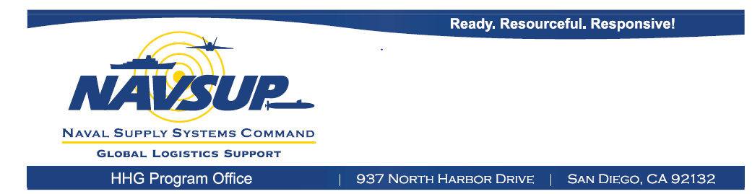

**You are cordially invited to attend the**

**2016 Navy Household Goods Industry Day**

**Subject to DoD Conference Approval**

**Registration deadline: February 24, 2016**

|  |  |  |
| --- | --- | --- |
| **City** | **TENTATIVE Date/Time** | **Location** |
| Norfolk, VA | Tuesday, March 1, 2016  0800 – 1600 | Doubletree by Hilton Norfolk Airport  1500 North Military Highway  Norfolk VA 23502 |
| San Diego, CA | Tuesday, March 15, 2016  0800 – 1600 | Anchors Catering & Conference Ctr  2375 Recreation Way/Yama St  Bldg 3210  San Diego CA 92136 |
| Jacksonville, FL | Tuesday, March 29, 2016  0800 – 1600 | Holiday Inn Hotel & Suites  620 Wells Rd  Orange Park, FL 32073 |

**Discussion Topics**

* 2016 Navy Household Goods Initiatives
  + Executive Move Program
  + Virtual Inspections
  + Center of Excellence
* Improving the move process
  + DPS
  + Communications
  + Member Support
* 2016 Peak Season
* Moving Industry concerns
* Open discussion

**Registration deadline is February 24, 2016.**

**Space is limited!**

Email registration form to: [householdgoods@navy.mil](mailto:householdgoods@navy.mil)

**NOTE: All conference events require Department of Defense approval.**

**Navy Household Goods**

**2016 Industry Day**

**REGISTRATION FORM**

**Register Early! Space is Limited**

**Registration deadline: February 24, 2016**

**Company Name : _____________________________________________**

**(Check location(s) attending)**

|  |  |  |  |  |  |
| --- | --- | --- | --- | --- | --- |
| **Attendee Name** | **Email Address** | **Phone #** | **Norfolk**  **(March 1, 2016)** | **San Diego**  **(March 15, 2016)** | **Jacksonville**  **(March 29, 2016)** |
|  |  |  |  |  |  |
|  |  |  |  |  |  |
|  |  |  |  |  |  |
|  |  |  |  |  |  |

**TENTATIVE** Date/Location:

March 1, 2016: Norfolk, VA (Doubletree)

March 15, 2016: San Diego, CA (Anchors)

March 29, 2016: Jacksonville, FL (Holiday Inn)

Check-in: 0730-0800

Meeting: 0800 – 1600

**Registration deadline is February 24, 2016.**

**Space is limited!**

Email registration form to: [householdgoods@navy.mil](mailto:householdgoods@navy.mil)

Questions: contact Deloma Miley at [deloma.miley1@navy.mil](mailto:deloma.miley1@navy.mil) or 619-532-1739

**NOTE: All conference events require Department of Defense approval.**